**CHAPTER 2**

**ANALYSIS OF EXISTING AND RELATED SYSTEMS**

This chapter indicates and explains the process of the existing system of Bataan White Corals Beach Resort. The processes that Mr. Noel Fulgar had presented, helped the proponents to anticipate on the problems of the present system of the resort. This also includes the related systems that are already implemented and tested that helped the proponents see and get an idea to make a synthesis of the developed system.

This study helps the proponents to get more knowledge for the system that the proponents are currently working on. The system analyzed and examined different occurrences of the system for a better result of the project by the proponents.

**REVIEW OF EXISTING SYSTEM**

**Description of the Existing System**

The old reservation system of the resort was a manual process. The resort was using Daily Occupancy Record (DOR) also called manual blocking and they have a print-out of it for the reservation. When the guest's reservation is not yet confirmed, it will be written using a pencil, but if the reservation is confirmed but not yet paid it will be written using a ballpen. If the reservation is confirmed by the guest, it will be shaded by their assigned color inside the office to know who is the responsible staff for that guest and then update the manual blocking in their excel. From the reservation process, modification, confirmation, and cancellation up to billing process, the transactions are all recorded in their Daily Occupancy Record (DOR).

The reservation process usually takes through phone call and email or using Facebook. The cashier or the manager usually handles inquiries of guests and provides the offer services and amenities of the resort. Either of the two can be in-charge of organizing and mark the dates of reservation. The billing of the said reservation will be acquired by the cashier or manager. The total bills will be given to the guest using their email included the mode of payment. And the client should send the deposit slip through email or Facebook to confirm the reservation and it is also required to present the official (deposit slip) personally to the front desk to verify their reservation.

The modification and cancellation of the process is also catered by the cashier or manager. This is where both of them will analyze and confirm the transaction through browsing the Daily Occupancy Record (DOR).

Although some are not present, potential gaps and problems may be present if the resort continues to use the same system. The proponents will analyze the old system and plot out the possible problems that may occur.

**Gaps/Problems of Existing System**

Bataan White Corals Beach Resort is using a reservation and billing system that they manually operate. They usually encounter gaps and problems which remains unsolved due to the kind of the system that they have. One of the gaps that they may encounter is giving the wrong information to the guests who might get confusions when asking the availability of the room and other services of the resort.

Since the process is manual, this means that the resort has no systematic way of processing transaction. The problem is, they do not have an organized process and the privacy of their records can be invaded easily by an unauthorized person. Because the DOR is just printed in a bond paper, it can easily be lost. Although they have a DOR in excel it is still a problem because they don’t have any back-up for the files.

In reservation, it is difficult to identify the date that is already marked. It can cause of overlapping of the schedules because of the manual process. The staff might plot the date where there is prior schedule, where the guest is already in terms of payment, the guest needs to present deposit slip in order to complete the transaction. This is actually not an issue until the guest does not have an email or social media account.

There would be times where they will have to deal with the slow processing of reservation when different guest arrives at the same time and make a reservation because DOR is only one. Also, the generation of the reports might not be accurate and not reliable most of the time.

**System Framework**

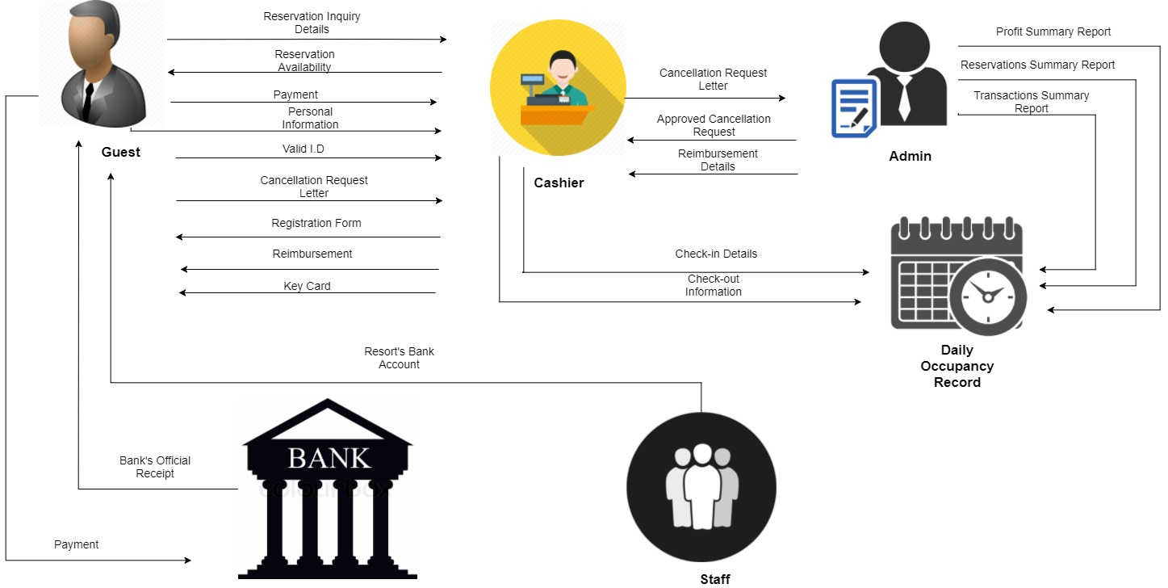

*Figure 1: System Framework Reservation and Billing System of Bataan White Corals Beach Resort*

Figure (1) corresponds to the System Framework of the Manual System of Bataan White Corals Beach Resort, which depicts the general flow and design of the system, its basic elements and the relationship between them.

The process starts with the guest calling Bataan White Corals Beach Resort to inquire for a room. The guest will give the cashier the date of their intended stay, then the cashier will be checking for all the available rooms and types of rooms on the said date of stay. The guest will be choosing a room and reserve it, after choosing a desired room the guest will now provide his/her personal information and a bank account will be given to the guest for the payment. After paying the reservation fee or full payment at the bank, an official bank receipt will then be issued to the guest. This official bank receipt will be sent to the email address of the resort to officially confirm the reservation. If the guest already paid for the reservation fee and an urgent cancellation wants to be made by the guest, the guest must first provide for a cancellation letter. This letter will only be approved by the admin if the reason is valid enough, and if so reimbursement is automatically made. Upon checking in the guest shall provide a valid identification card. Once confirmed, the guest will be given a registration form for the terms and conditions of the resort and also serves as the official receipt. After filling up the registration form the guest will now be given the key card and will be directed to their designated room. Check-in and check-out information will be listed on the daily occupancy record. A report will then be made for every guest that the resort had, like transaction summary, reservation summary and profit summary.

**DATA FLOW DIAGRAM**

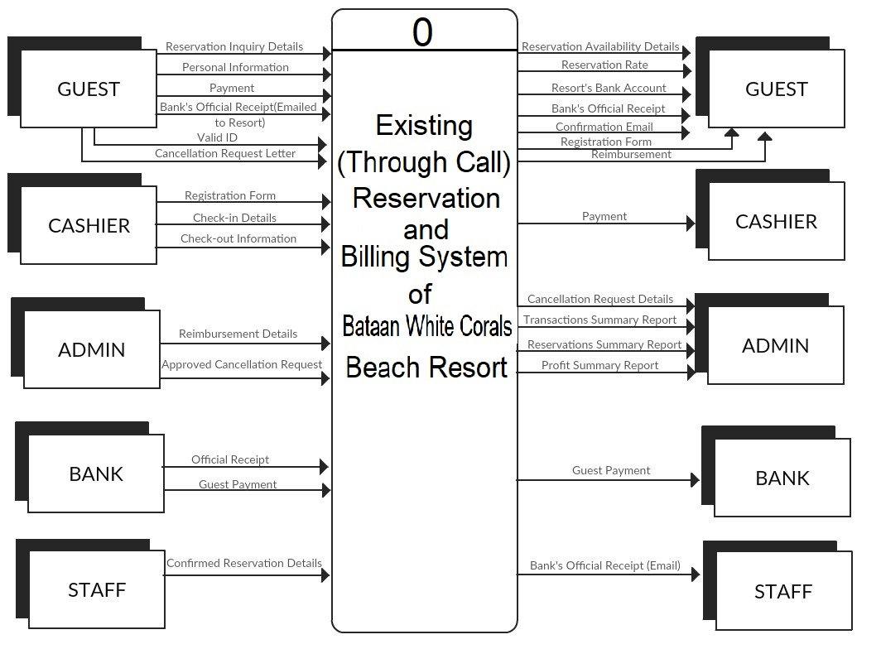**Context Diagram**

*Figure 2: Context Diagram of the Existing System Reservation and Billing System*

In Figure 2, the Context Diagram shows how the entities interact with the system. This also shows how the entities send and receive data in and out of the system.

The guest is the main source of data of the system. The guest will inquire available reservation on his/her desired date. After confirming the availability of the desired date, the guest will be informed of the billing details of his/her reservation. The guest will also be asked to provide his/her personal information needed for the completion of transaction. The guest will pay either initial or full payment through the resort’s BDO account on or before the given deadline. After depositing the payment to the BDO account, the guest will send the picture to the resort’s email address or Facebook account for the confirmation of the reservation.

Upon check-in of the guest, he/she will be needed to present a valid ID and the Bank’s Official Receipt in order to be recognized. If the guest only paid the down payment, he/she will have to pay his/her remaining balance to the cashier. Once the account of the guest is cleared, a registration form will be given to the guest and will be asked to fill-up the necessary information. After filling-up the registration form, a key card will be given to the guest. The registration form also serves as the official receipt of the resort. The given key card has the access to the room of the guest.

Upon check-out of the guest, he/she will only give back the key card and the cashier will record his/her check-out information.

Cancellation request letter is also provided by the guests if he/she wants to cancel his/her reservation. In the cancellation process, the cashier will be the one who will return the paid amount to/by the guest.

When it comes to approval of the cancellation request, the admin is the one who decides whether the cancellation of reservation’s reason is valid. Reports like total reservations, total transactions, and total profit will all be computed and compiled by weekly, monthly and yearly. The reports will be received by the management.

**Diagram 0**

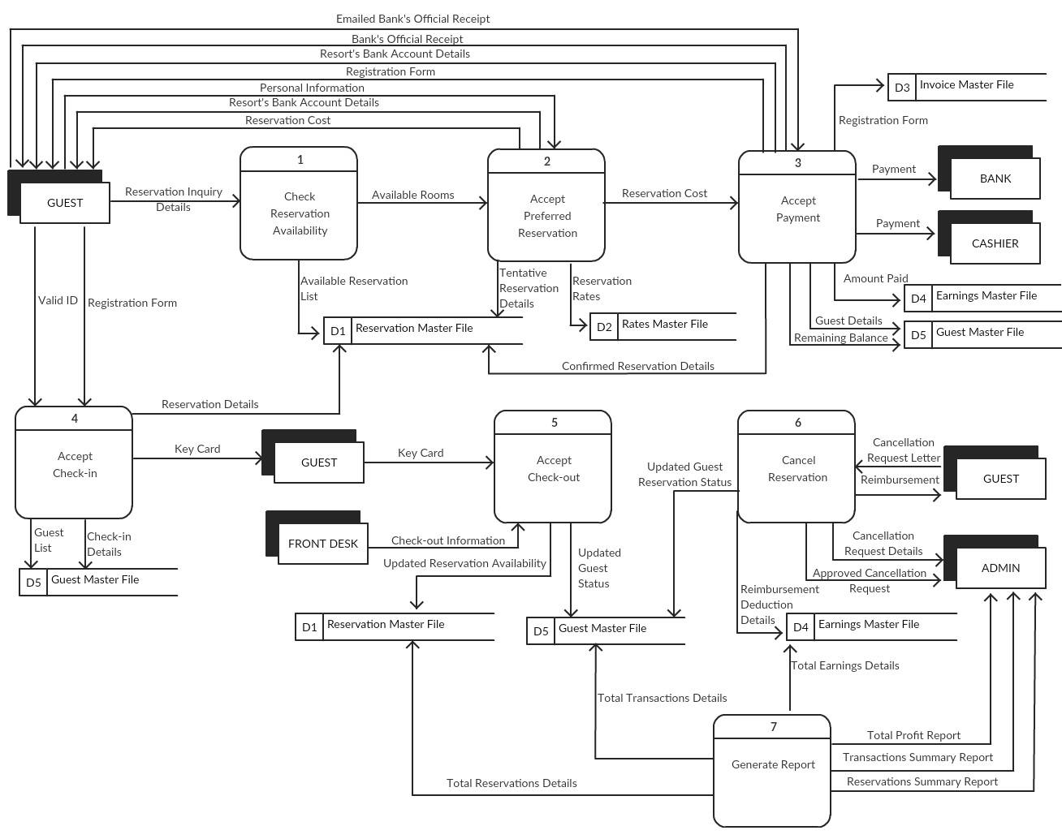

*Figure 3: Diagram 0 of the Existing System Reservation and Billing of Bataan White Corals Beach Resort*

In the first process which is Check Reservation Availability accepts Reservation Inquiry Details of a guest. From the Reservation Master File, the Available Reservation List will be inherited. If the desired reservation is available, it will proceed to Process 2 which is the Acceptance of the Preferred Reservation with the preferred available room. The guest will be asked to provide his/her personal information and the resort will give their BDO account where the guest will deposit his/her payment. From the Rates Master File, the guest will know the price and rate of his/her reservation. The Tentative Reservation Details will be stored to the Reservation Master File using pencil.

After the guest gives his/her personal information and knowing where to deposit the payment, it will now proceed to Process 3, the Acceptance of Payment. In BDO bank, where the money will be deposited by the guest, his/her contact number and the given bank account of the resort will be provided by the guest before he/she deposits the money. After the guest has deposited the money for his/her payment, a receipt will be issued to prove that he/she has deposited cash. The bank’s official receipt will be scanned by guest and will send it to the resort’s email address or Facebook account to confirm that he/she has deposited the payment. In return, the guest will also be sent a confirmation email stating that his/her payment has been received and the reservation made is confirmed. From pencil to ballpen, the staff will then update the Reservation Master File to confirm that the guest has deposited an amount to pay for his/her reservation. The amount of the deposited cash will also be recorded to the Earnings Master File. Guest Information will also be stored to the Guest Master File with the Remaining Balance of the guest (if any).

After having the issued receipt of the bank, it will proceed to the Process 4, the Check-in Acceptance, the guest will be asked to show the Bank’s Official Receipt and a valid I.D for validation purposes. From the Guest Master File, the information like Guest List, Remaining Balance (if any) and the Check-in Details will be inherited. The guest will also be asked to fill-up a Registration Form for the terms and condition of the resort and also serves as the official receipt. One copy will be the guest’s copy and another copy are for the resort to be stored on the Invoice Master File. After filling-up the Registration Form, a key card will be given to the guest. The given key card has the access to the guest’s room.

The Process 5 is the Acceptance of Check-out, the guest shall give the key card and from the Guest Master File, the Check-in Details will be inherited. The cashier will then record the Check-out Information of the guest. The Reservation Master File and Guest Master File will be update for the availability of the room and the status of the guest.

In Process 6, the Cancellation of Reservation, the guest must have to send a Cancellation Request Letter to the Admin. Once the request is approved by the management, reimbursement will be given to the guest. After the Management approves the letter, the Earnings Master File, Guest Master File and the Reservation Master File will be updated.

For the last process is the Generation of Reports such as Reservations, Transaction Summary and Total Profit Reports. The reports will be received by the Management.

For the formalities of the diagram and to be clear, Diagram 0 shows that the data flows through different Master Files but in real situation, all the reservations and billing data are all written inside one logbook which is the Daily Occupancy Record (DOR).

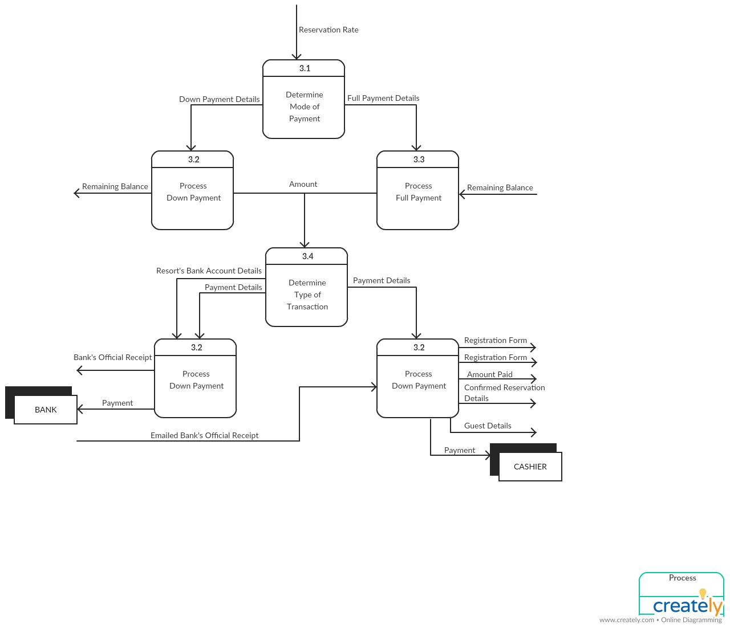

*Figure 4: Child Diagram*

The Figure 4 determines the mode of payment and the remaining balance of the guest whether the guest paid the down payment of fifty percent (50%) or fully paid the total amount of the reservation. In Process 3.2, the remaining balance will be computed from the difference of the total amount and the amount paid through bank account. The computed remaining balance must be settled in order to proceed to Process 3.3 which is the process of full payment. Process 3.4 will determine the type of transaction made by guest in which if the reservation was through call the guest will pay directly to the bank; if it’s walk-in the guest will proceed to the cashier. Upon completion of the payment the guest will receive a registration will be given to the guest and the other copy will be stored on the Invoice Master File and check-in details will be recorded on the Guest Master File.

**SWOT ANALYSIS**

*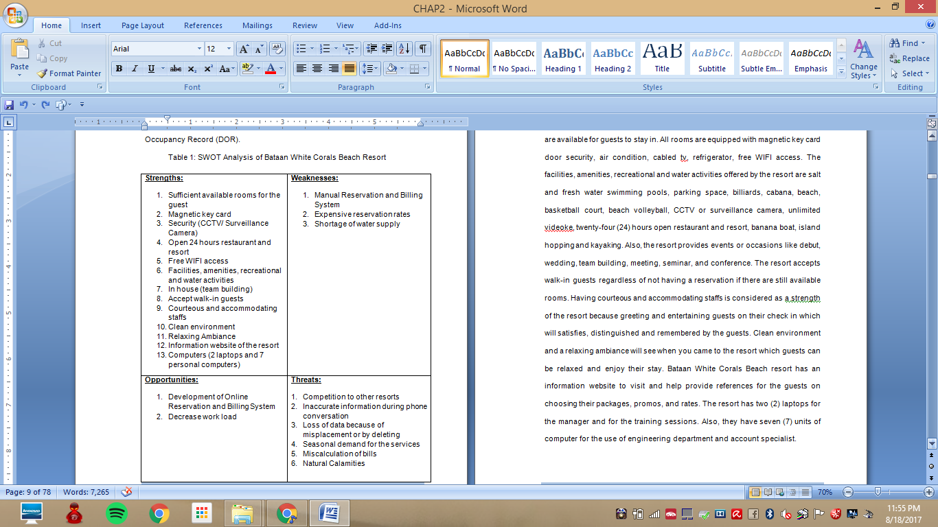Table 1: SWOT Analysis of Bataan White Corals Beach Resort*

**Strengths**

Bataan White Corals Beach Resort has a total of ninety-one (91) rooms that are available for guests to stay in. All rooms are equipped with magnetic key card door security, air condition, cabled tv, refrigerator, free WIFI access. The facilities, amenities, recreational and water activities offered by the resort are salt and fresh water swimming pools, parking space, billiards, cabana, beach, basketball court, beach volleyball, CCTV or surveillance camera, unlimited videoke, twenty-four (24) hours open restaurant and resort, banana boat, island hopping and kayaking. Also, the resort provides events or occasions like debut, wedding, team building, meeting, seminar, and conference. The resort accepts walk-in guests regardless of not having a reservation if there are still available rooms. Having courteous and accommodating staffs is considered as a strength of the resort because greeting and entertaining guests on their check in which they will be satisfied, distinguished and remembered by the guests. Clean environment and a relaxing ambiance can be seen when the customers come to the resort which make them relax and enjoy their stay. Bataan White Corals Beach resort has an information website to visit and help provide references for the guests on choosing their packages, promos, and rates. The resort has two (2) laptops for the training sessions and for the manager and seven (7) units of computer for the use of engineering department and account specialist.

**Weaknesses**

When it comes to weaknesses of the company, having no Online Reservation System is one of Bataan White Corals Beach Resort’s dilemma. Thus, it only has a manual reservation and billing system that end up with slow reservation transactions. The resort also offers an expensive reservation rates. Shortage of water supply is sometimes a problem in the resort.

**Opportunities**

Every owner of the resort must be willing to make or accept changes for the better sake of the company. Since the Bataan White Corals Beach Resort has already an available information website. For the resort to be efficient, proponents will provide and develop an Online Reservation and Billing System. Also, to help decrease workloads of the management such as paper work or manually writing down data or information of guest’s reservation.

**Threats**

There are reasons that are considered risks which can be experienced by the company. Competition to other resort is one of a great threat to Bataan White Corals Beach Resort. Since the resort’s location is at Morong, Bataan many resorts are built that are much nearer compare to the location of the resort that some guests prefer to stay in. Having a vacation or swimming is in demand when it comes to summer season for the resort but when it comes to off peak season such as rainy days and months of June to December guests tend to not come which the resort is unoccupied. A loss of data because of misplacement or accidentally deleted files mainly if the resort doesn’t have any back up files of records. Also, miscalculation of bills because it can lead to doubts of guests and unbalanced records between record and receipt. Regarding natural calamity it is also considered as a threat because guests may not come or cancel their reservation when a calamity is occurred.

**REVIEW OF RELATED SYSTEMS**

The following systems are systems related to the developed system. These systems present the features of the related systems that are useful for the project. This information will definitely help the proponent to execute the best solutions for an accurate outcome of the developed system. These will be the basis of the proponent's study.

**LOCAL**

**THE MANILA HOTEL**

On the Second Philippine Commission William Howard Taft issued the first decree to create an urban plan for Manila. He assigned Daniel Hudson Burnham an architect and the city planner, he drafted a wide long tree-lined boulevard that would begin at the park and at the spit's end of the bay, a boulevard that would be dominated on one end and that is a hotel, Manila Hotel. The Manila Hotel is the oldest premiere hotel in the Philippines built in 1909 with 149 spacious and high ceiling rooms to be in competition with [Malacañang Palace](https://en.wikipedia.org/wiki/Malaca%C3%B1ang_Palace), the official residence of the President of the Philippines. Manila Hotel was established on July 4, 2012 in commemoration of American Independence. The original design of the hotel was an H-shaped plan that focused on well-ventilated rooms, providing grand vistas of the harbor, the Luneta and Intramuros. In present time, Manila Hotel is widely known as the tallest hotel in Manila Bay, oldest premiere hotel, finest and the most exquisite hotel nationally.

The hotel is popular not only nationally but internationally for its elegant and exceptional rooms and world-class services, the hotel accommodated numerous world historical persons, celebrities including authors. They also host special events and unique amenities for its guests. Hosting some big events like birthdays, conference and weddings are one of the specialties of the Manila Hotel. Their dining also varies in different types including their famous Café Ilang-Ilang, Delicatessen, Pool Bar, Lobby Lounge, Tap Room, Cowrie Grill and so much more. It proudly shows nine live cooking stations and features to a wide array of local and international cuisines.

Manila Hotel currently has a total room of 570 with various types of suites and rates. The building is located on One Rizal Park, Manila. In line with the engaged life where the hotel was established, the Manila Hotel being a highly demand elevates the use of their online reservation system through the use of their website not only to lessen the effort by being physically at the hotel to book but also to uphold convenience for their guests.

The Manila Hotel provides a website to communicate with their guest. Their website is equipped with information regarding the hotel and its services; it also has an online reservation system that allows their guests to reserve a room.

The following are screenshots of processes on how a guest reserves a room in The Manila Hotel using its online reservation through their website.

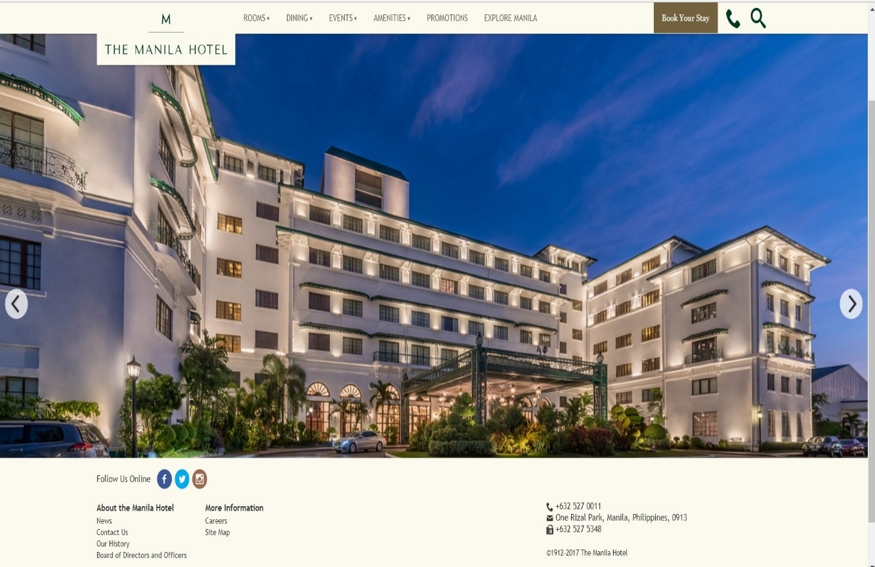

*Figure 5: (The Manila Hotel) Homepage*

* The guest can select to view first the rooms, dining, events, amenities, promotions; and it also has a feature to explore Manila which when clicked shows some tourist spot near and accessible to Manila Hotel.
* The guest can reserve a room by the button "Book Your Stay".

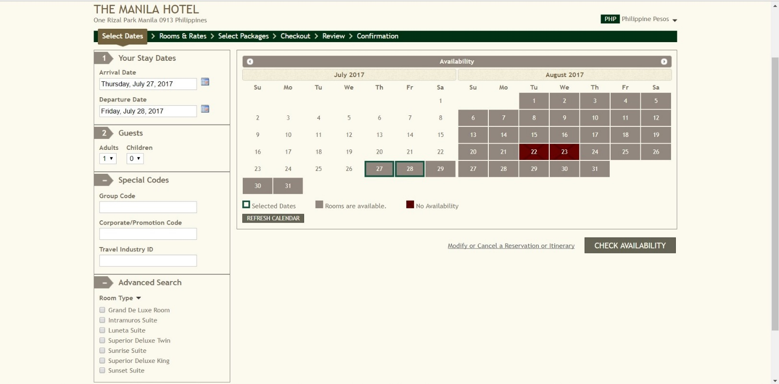*Figure 6: (The Manila Hotel) Room Reservation*

* The guest provides his/her check-in and check-out date. The one with the green highlight in the corner of the box, means it’s the selected date of the guest, red shaded box means unavailability of the room on the said day and gray shade box means available rooms
* The guest must input how many the occupants would be (number of adults and children).
* The button "Special Codes" the guest may also input codes for a promo either be a group code, corporation and travel industry.
* The button "Advance Search" shows the various type of rooms and you may choose your preferred suite.
* 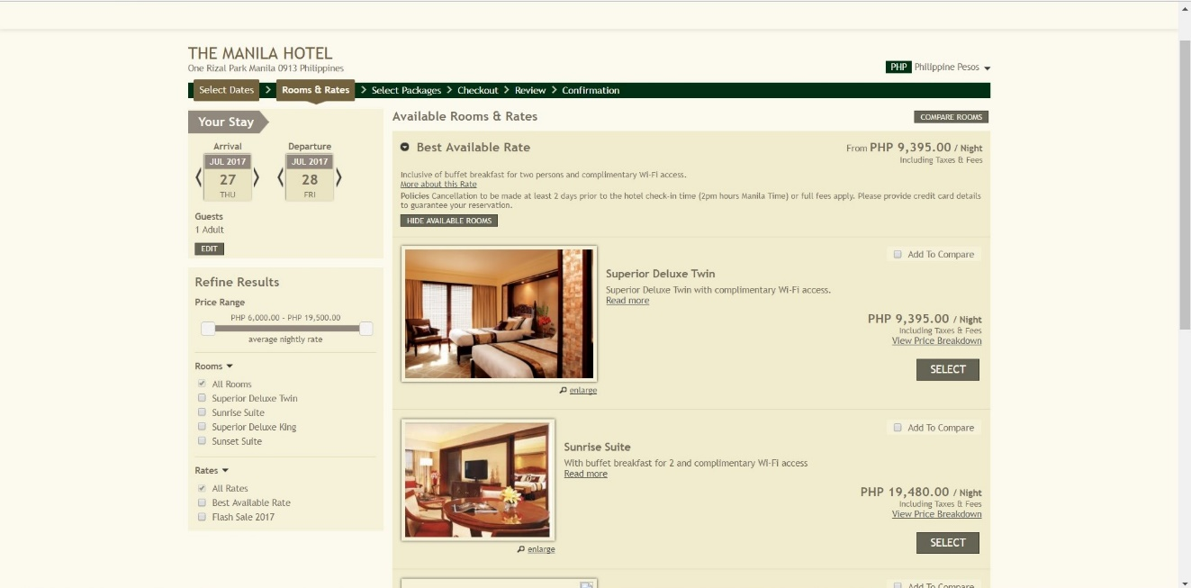The button "Check Availability" shows the available rooms according to guest's inputs.

*Figure 7: (The Manila Hotel) Room Reservation)*

* After inputting check in and check out date and number of adults & children, the next page will show the available rooms the guest can book.
* The guest can compare first the selected rooms she/he wants and then can select which of the room she wants to avail.

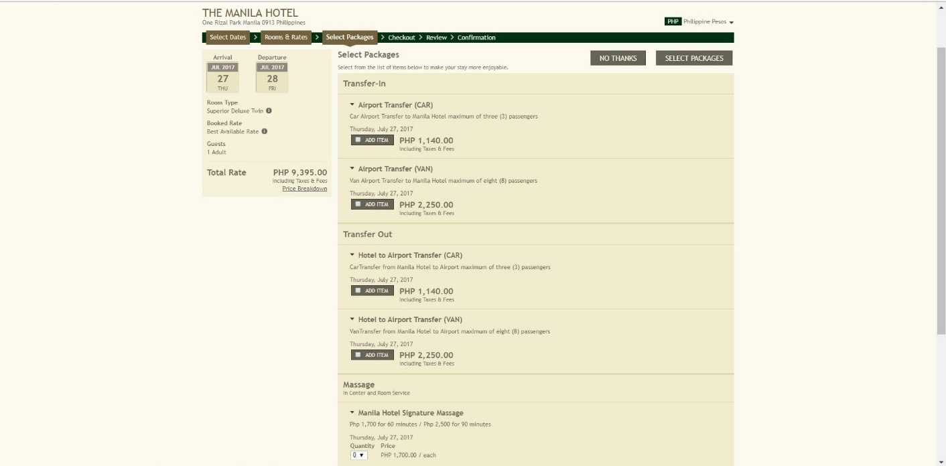*Figure 8: (The Manila Hotel) Selecting Packages*

* The guest may or may not choose to avail some of the services the hotel has.

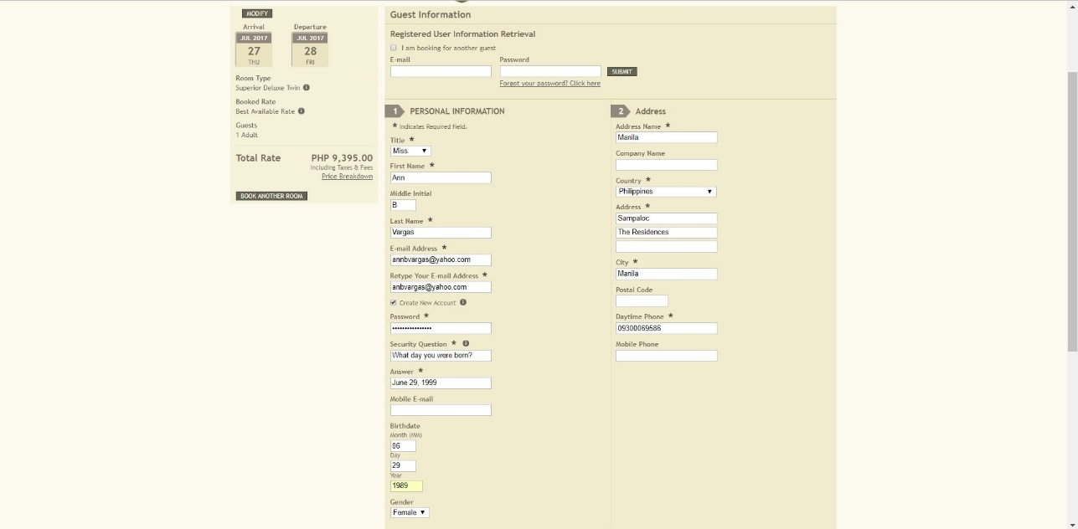*Figure 9: (The Manila Hotel) Guest Information*

* The guest may sign in via his/her registered account.
* Or fill up his/her Personal Information.
* The guest may choose if she/he wants to create an account or not.
* Stay Summary with the total costs are on the left side of the page.
* On this step, the guest may add another booking reservation.

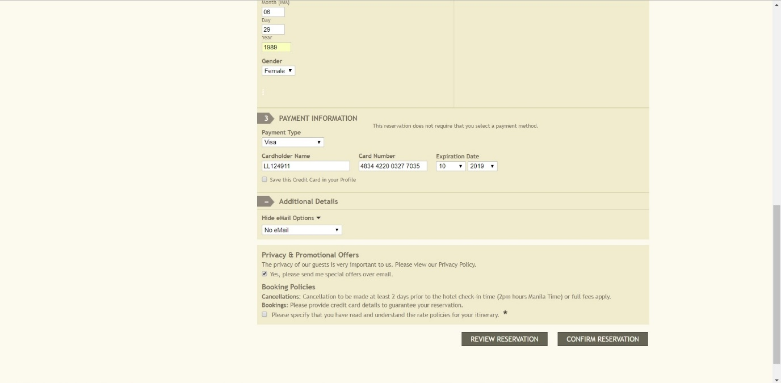*Figure 10: (The Manila Hotel) Payment Information*

* The guest's credit card number is used to hold his/her reservation. It will not be charged at booking.
* The guest must input his/her name, credit card number and expiration date.
* The guest may choose whether to receive an email or not.
* The credit card number used in this screenshot is for test purpose only.

*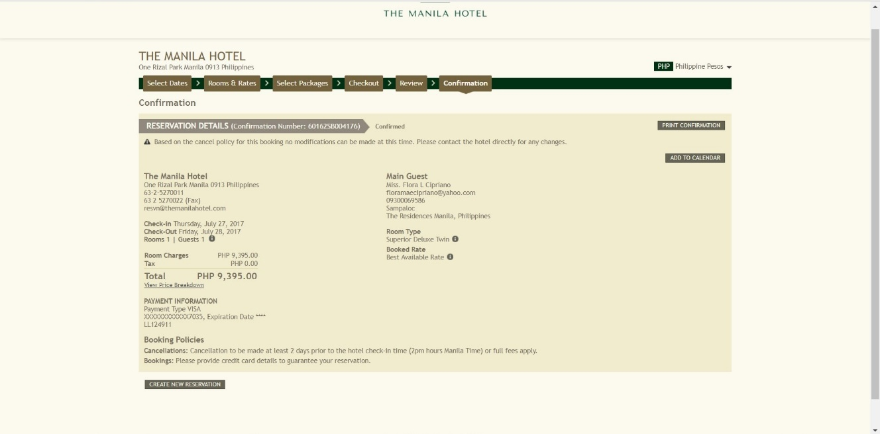Figure 11: (The Manila Hotel) Booking Confirmation*

* The guest will be given a Confirmation Number for a unique identification of the reservation.
* A confirmation will be received by the guest.
* Stay summary and Total Cost are displayed.
* The guest can print this confirmation.

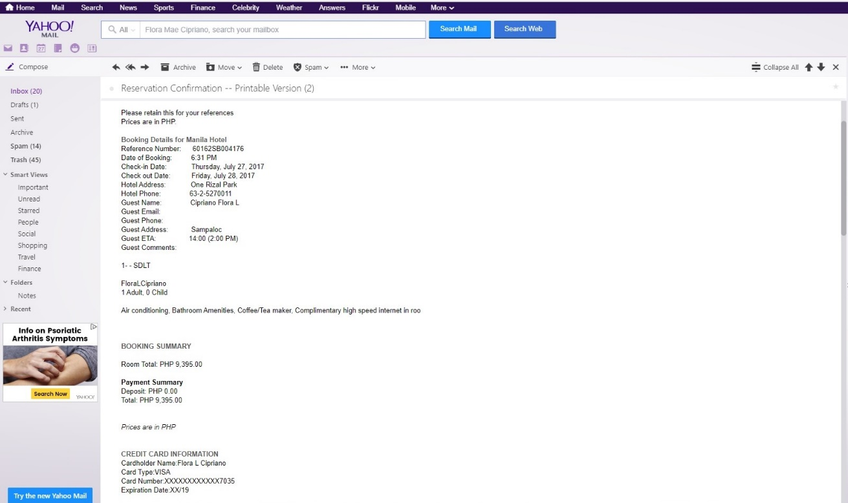*Figure 12: (The Manila Hotel) Reservation Confirmation E-mail*

* The confirmation e-mail contains the complete reservation details.

*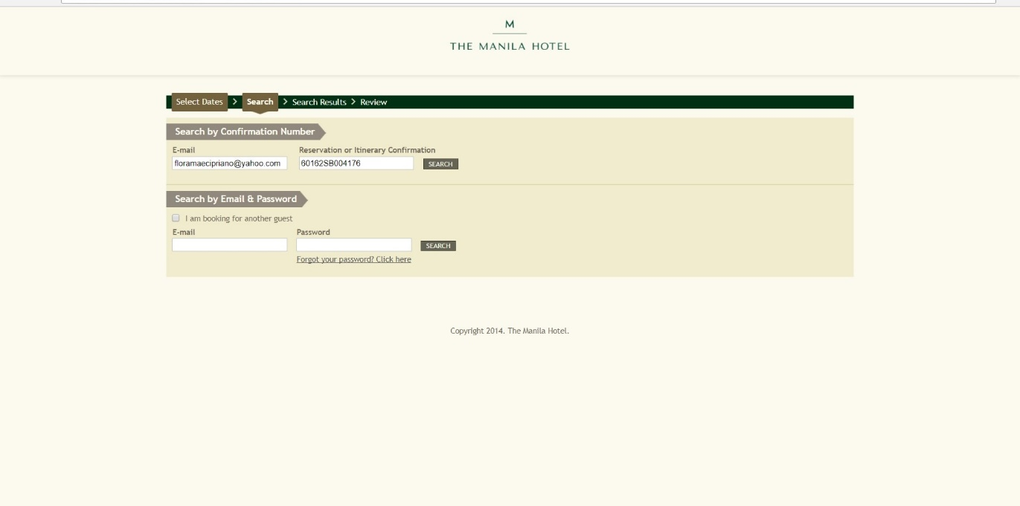Figure 13: (The Manila Hotel) Modify/Cancel Reservation 1*

* To view, modify or cancel the existing reservation, the guest should navigate to Room Reservation, click Modify/Cancel Reservation or Itinerary.
* The guest should provide their e-mail and Reservation Confirmation.
* Or log-in as a registered account.

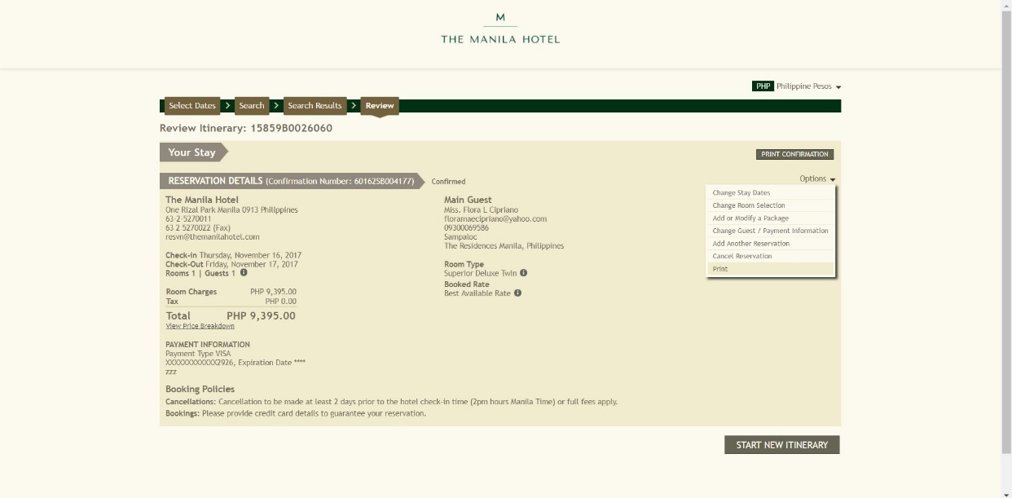*Figure 14: (The Manila Hotel) Modify/Cancel Reservation 2*

* The guest can also view his/her reservation details and may edit it.
* The Booking Policy is shown at the lower part of the page and Cancellation button is on the right side of the page with other options to modify your reservation.

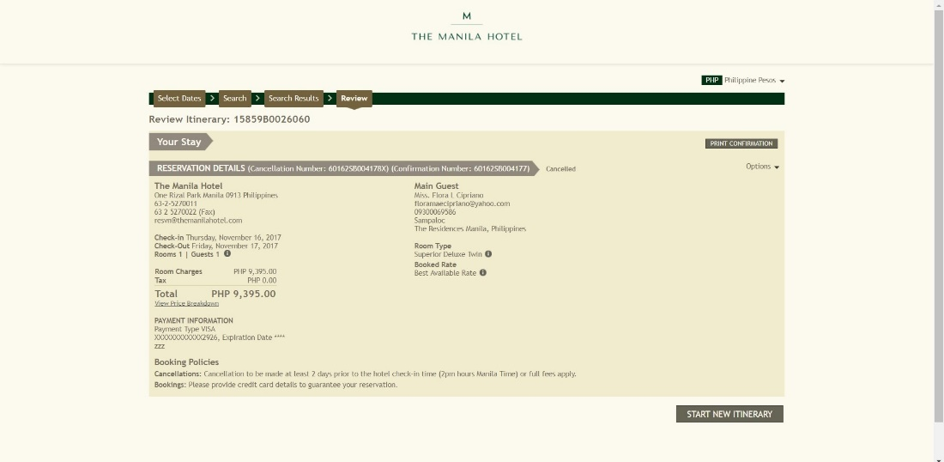*Figure 15: (The Manila Hotel) Cancel Reservation 2*

* After the Cancel Reservation is clicked, the guest will receive a Cancellation Number.
* The cancellation number will serve as a unique identification of the cancelled reservation.

**LAS CASAS FILIPINAS DE ACUZAR**

The name Las Casas Filipinas is inspired by a Spanish term which means Philippine Houses, it is a unique Spanish-Philippines heritage. In 2003, Gerry Acuzar the owner of the resort started to rebuild the Spanish colonial-era mansions. Las Casas was established in 18th to 19th century, with its 27-main attraction of mansions, mostly from Pampangga, Nueva Ecija, Meycauyan, Tuguegarao and old Manila. Some of them are replicas but most are originals collected from various parts of the Philippines. It was formally opened to public in 2010.

The Hotel and Resort is popular nationally with their historical and exceptional rooms and services. Not only they feature the old mansions, but they also host special events and provide amenities to its guest. The Las Casas culture believed that the legacy of our forefathers and beautiful customs and traditions are to be preserved through the restoration of the houses. Las Casas yearns for Filipinos to take a look back at the past, and re-live the traditions and practices that are distinct to our culture. Water activities and day tour are among the specialties of Las Casas, they provide various types of leisure for the guest.

Las Casas consists of more than 70 rooms and suites with different types and rates. The Hotel is located at Bagac Bataan, 20kilometers away from Mt. Shrine and just near Bagac Bay. In line with the rural, relaxing atmosphere and a few hours away from the city life where the hotel is situated. Las Casas being a tourist spot nationally promotes the use of their online reservation system through their website for the reason that their location is a bit and it will be an inconvenience to their guest to book through walk in.

Las Casas provides a website to communicate with their guest. Their website is equipped with information regarding the hotel and its services; it also has an online reservation system that allows their guest to reserve a room.

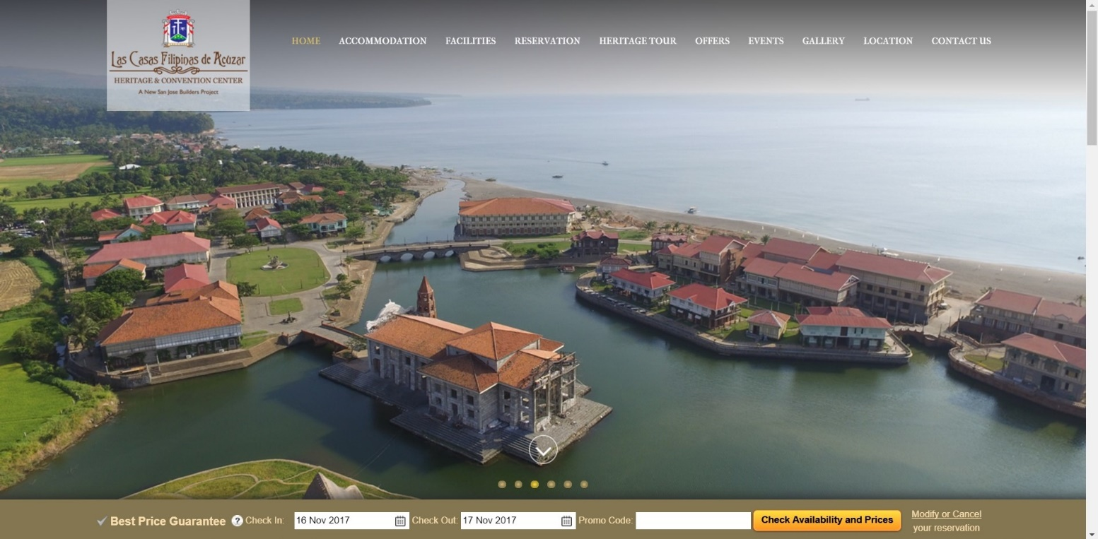The following are screenshots of processes on how a guest reserves a room in Las Casas using its online reservation through their website.

*Figure 16: (Las Casas Filipinas De Acuzar) Homepage*

* The guest can reserve a room by the button "Reservation"
* On the lower part of the page the guest can directly input the check in and check out.
* 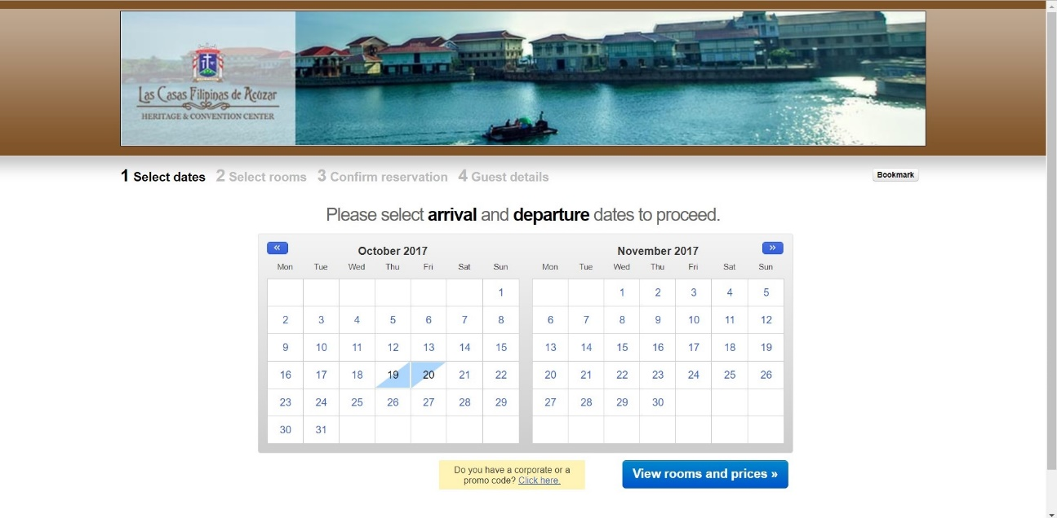The button "Check Availability and Prices" shows the available rooms and prices according to the guest's inputs.

*Figure 17: (Las Casas Filipinas De Acuzar) Selecting Dates*

* The guest can select his/her check in and check out.
* The button "View Rooms and Prices" shows the available rooms and their specific rates according to guest's inputs.

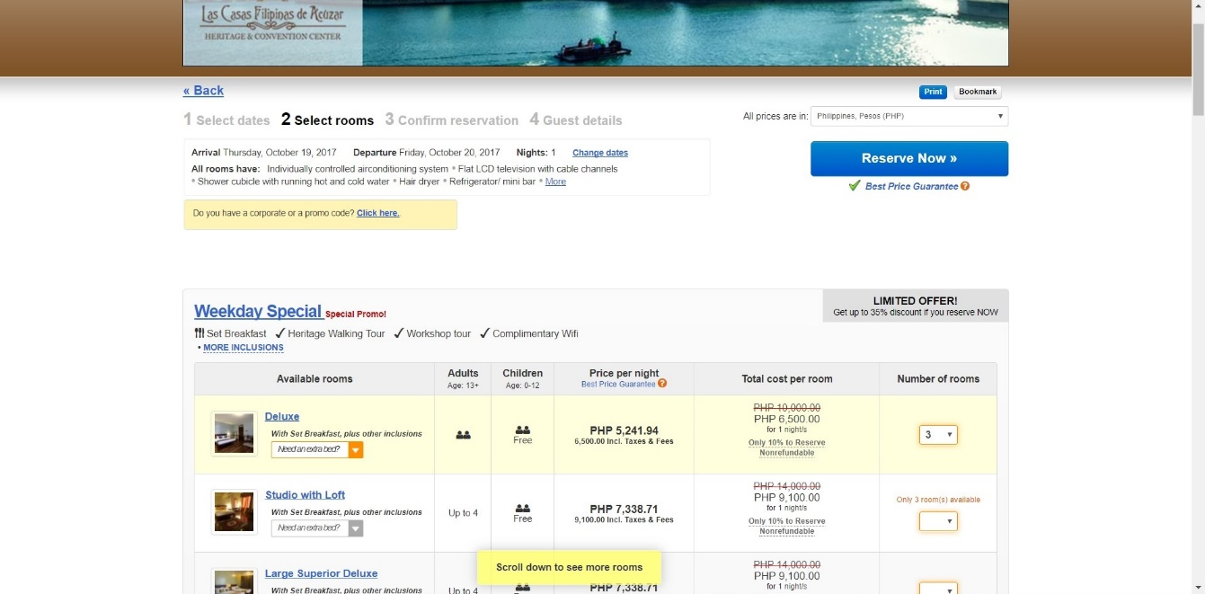*Figure 18: (Las Casas Filipinas De Acuzar) Room Reservation*

* After inputting check in and check out, the button "Reserve Now" will show your Stay Summary and Total Cost.

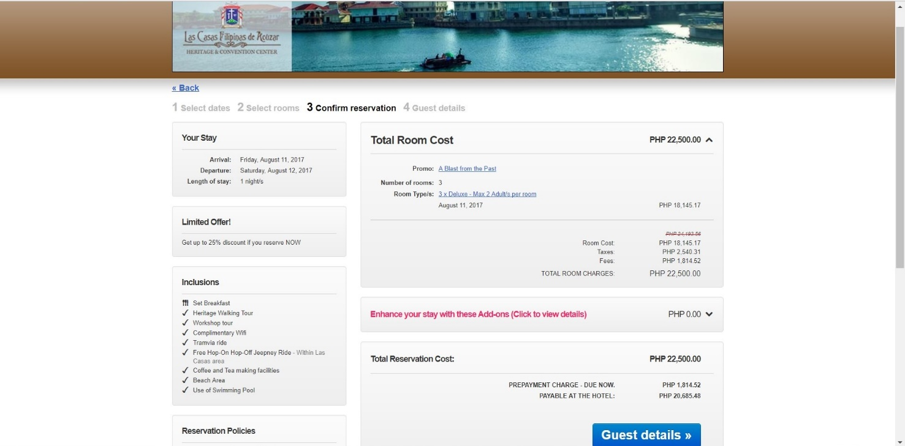*Figure 19: (Las Casas Filipinas De Acuzar) Confirm Reservation*

* The guest can view Stay Summary, Inclusions of the Reservation, Reservation Policies and the Total Cost.
* The guest can also choose to avail some add-ons that the hotel offers like water activities for the rest of their stay.

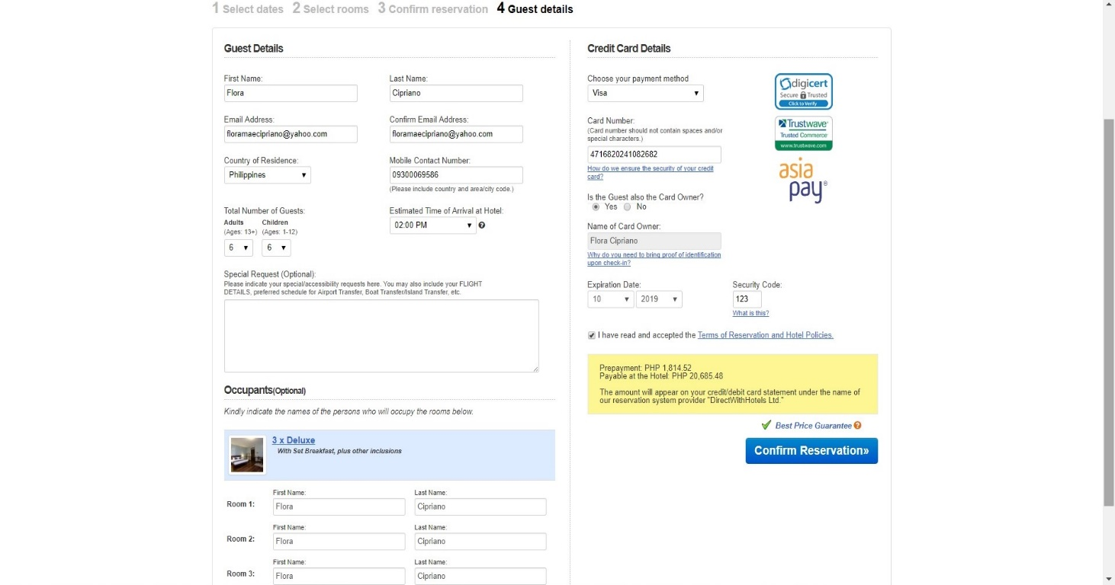*Figure 20: (Las Casas Filipinas De Acuzar) Guest Information*

* The guest must fill up the information needed, at this step the guest will now input the number of adults and children.
* Special requests are also available when the guest will input his/her remarks.

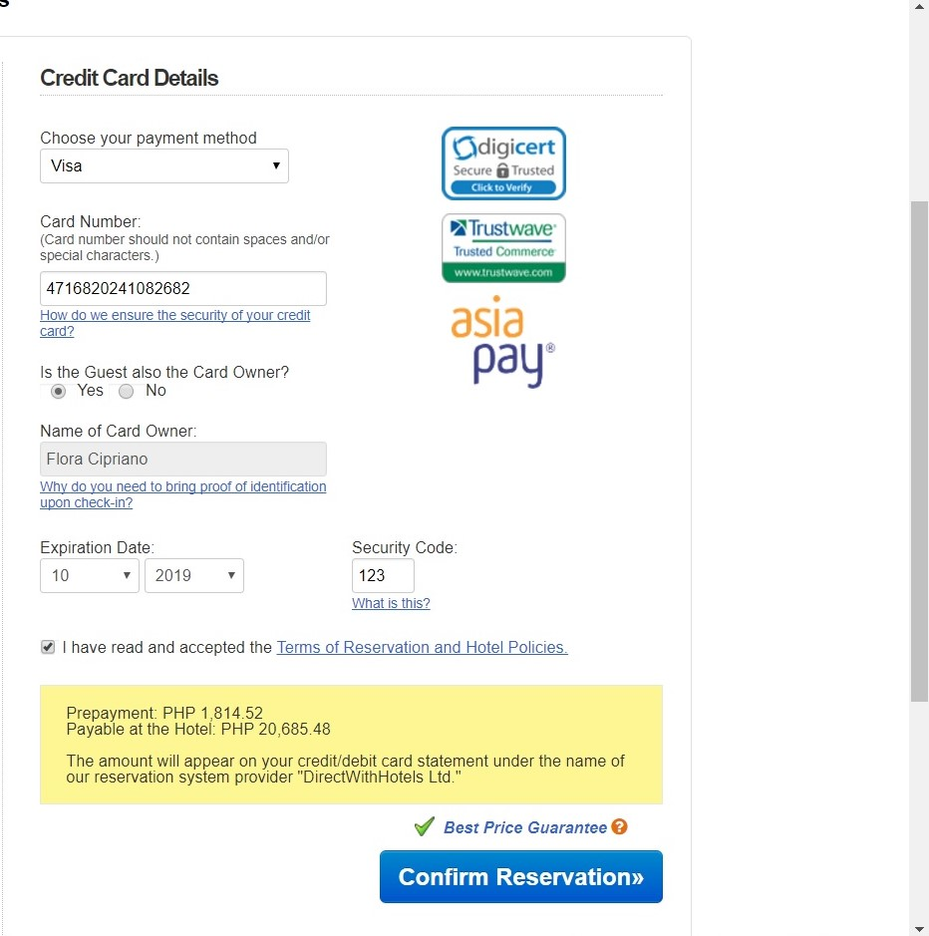*Figure 21: (Las Casas Filipinas De Acuzar) Credit Card Guarantee*

* The guest must enter his/her credit card number, determine card type, card's expiry date and security code.
* The credit card number is used in this screenshot is for test purpose only.

**CROWN REGENCY HOTEL**

The first Crown Regency Hotel was established in 2005 located in Cebu being known as the tallest building outside Metro Manila. In present time, the group compromises over 10 high-class hotels nationwide specifically in Manila, Cebu, Davao and Boracay. The Crown Regency is known as one of the finest and most exquisite hotels and resorts in the Philippines.

Crown Regency Hotel believes that with a state of the art facilities, restaurants that serve sumptuous and a fine class dining and with the courtesy of the employees who consistently provide excellent service for every guest, their dedication to continuously deliver services will satisfy the needs of the guest. The Hotel and Resort is popular for their exceptional and finest rooms and a high-class service. Not only they provide rooms but they also host convention and provide various amenities to its guest.

In Boracay, four hotels were established, with a total of more than 780 rooms. One of the hotels, Crown Regency Beach Resort is located at Station 3, Boracay Island. Inspired by the airy breeze and quiet surroundings of the Station 3 beachfront this beach resort owes its bright Zen architecture to the laidback atmosphere of an island life. In line with how popular where the building is situated, Crown Regency Hotel being a high demand hotel promotes the use of their online reservation system through their website to elevate convenience for their guest.

Crown Regency provides a website to communicate with their guest and other branches around the country. They use a single website that has a different sub domain categorize into their different branches. Their website is equipped with information regarding the hotel and services; it also has an online reservation system that allows their guest to reserve in any of their branches.

The following are screenshots of processes on how a guest reserves a room in Boracay Crown Regency Beach Resort using its online reservation through their website.

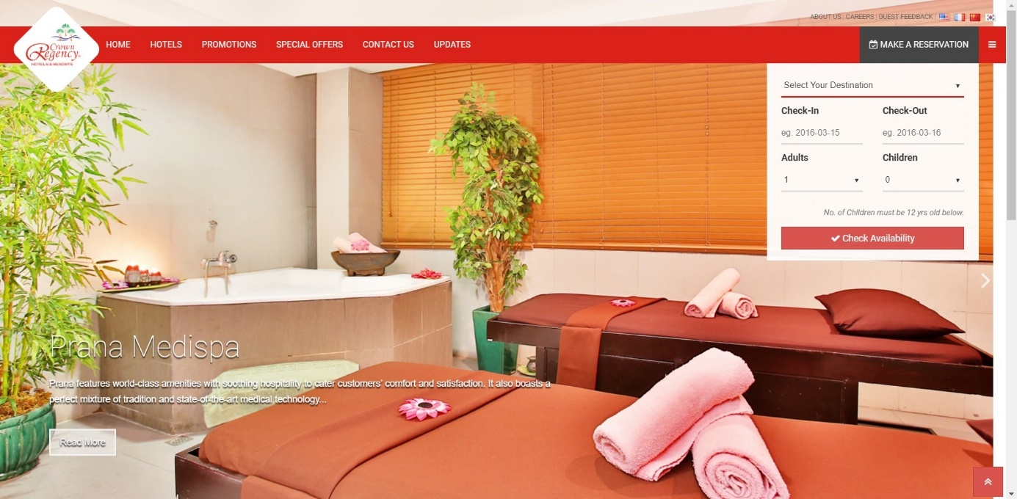

*Figure 22: (Crown Regency Hotel and Resort) Homepage*

* The guest selects what branch to check in by selecting which hotel. The guest also provides his/her check-in and check-out date.
* The guest must input how many the occupants would be (number of adults and children).
* 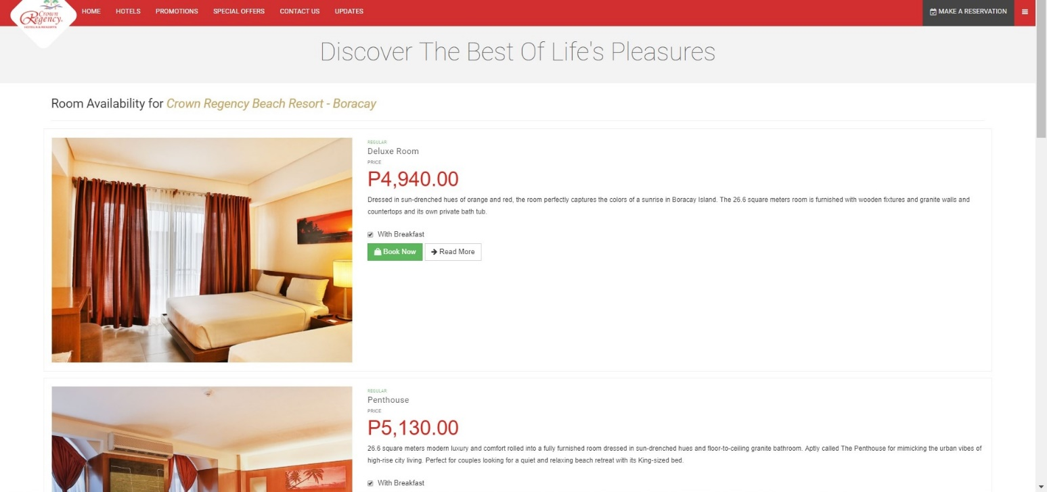The button "Check Availability" show the rooms available and rates according to guest's inputs.

*Figure 23: (Crown Regency Hotel and Resort) Room Reservation*

* After inputting check in and check-out date, adults and children, the next page will show the available rooms the guest can book.

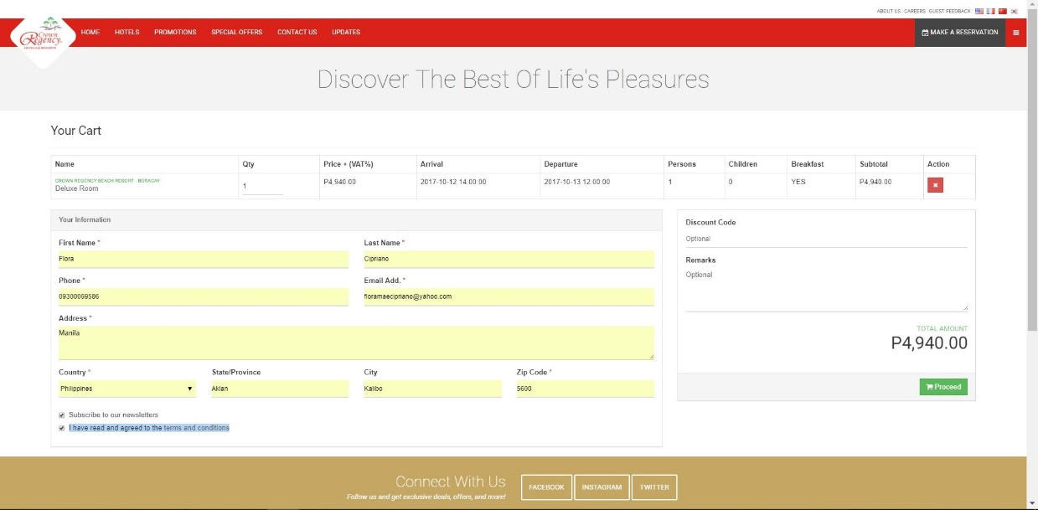*Figure 24: (Crown Regency Hotel and Resort) Guest Information*

* The guest must fill up his/her Contact Information.
* The guest may choose whether to subscribe in their newsletter or not.
* Remarks are also available for the guest if they have a special request.
* Stay Summary and Total Cost are shown at the top of the page.

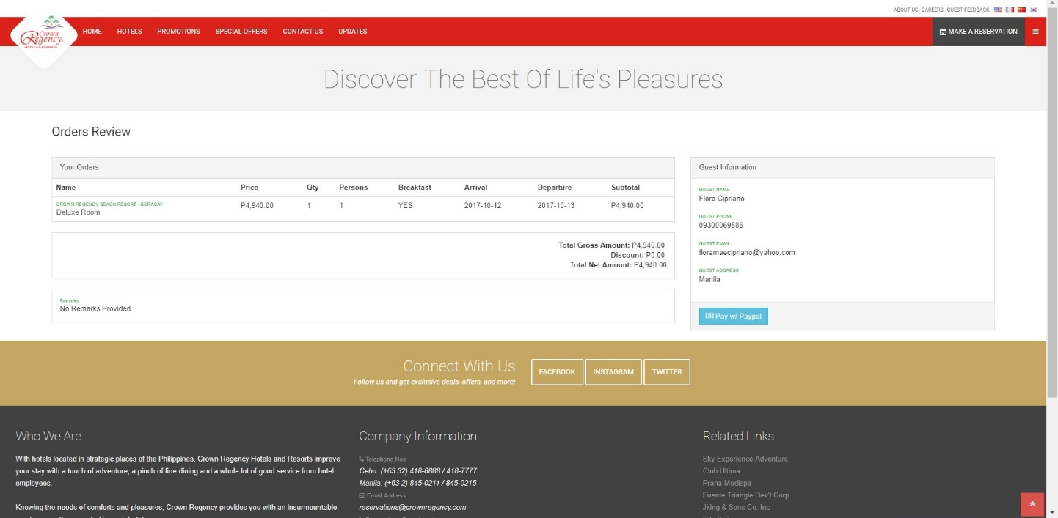

*Figure 25: (Crown Regency Hotel and Resort) Reservation/Order Review*

* Stay Summary, Total Cost, Guest Information is displayed.
* The button "Pay with Paypal" directs you to payment method.

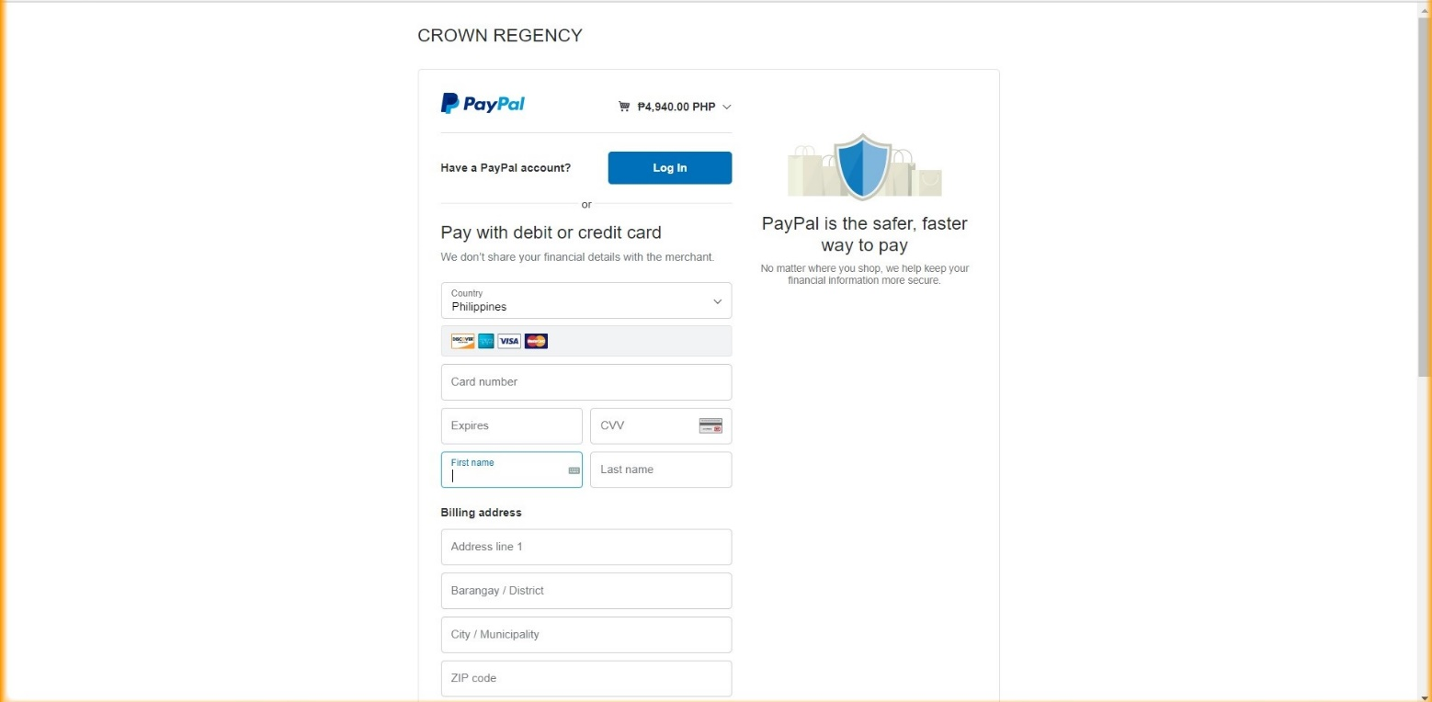

*Figure 26: (Crown Regency Hotel and Resort) Credit Card Guarantee*

* The guest must enter his/her credit card number, determine card type, card's expiry date and CCV.

**FOREIGN**

**GRAND SIERRA HOTEL AND CASINO**

Formerly MGM Grand Reno, Bally's Reno and Reno Hilton to its final name Grand Sierra Resort. It was established in 1979 upon proposing to scout out Reno locations after their very high-profile Las Vegas Casino. From MGM Grand Reno, it was passed to Bally's Reno its final Grand Sierra for the cause of bankruptcy. The Grand Sierra is now owned by The Maruelo Group. The name Grand Sierra is known that has the largest casino floors and as one of the finest and most exquisite hotel and resort in Reno, Nevada, U.S.

The hotel is popular internationally with their luxurious and exceptional rooms and high-class services. Aside from the rooms, they also host conventions, weddings and other various amenities to their guest. The hotel also has a shopping center, pool, 50-lane bowling alley, movie theater, nightclubs, Sports Boo, and a lake golf driving range. They consist of 10 restaurants, including a celebrity chef who owns two of it. Their casino is also one of the mainstreams of the hotel being the largest casino floor in Reno, Nevada.

Grand Sierra Hotel and Casino consists of 2,001 rooms and suites with different types and rate. The building is located at the intersection of Mill and 2nd Streets at Reno, Nevada. With the hotel's various amenities and activities that they offer, without a doubt even from different countries want to avail their rooms. Being a high demand hotel, they promote the use of their online reservation system through their website to elevate convenience for their guest from different parts of the world.

Grand Sierra Hotel and Casino provides a website to communicate with their guests. Their website is equipped with information regarding the hotel and its services; it also has an online reservation system that allows their guests to reserve a room.

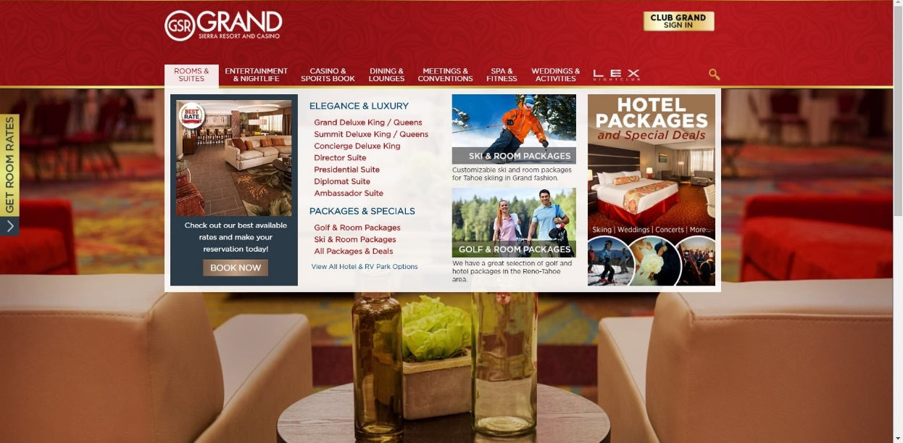The following are screenshots of processes on how a guest reserves a room in Grand Sierra Hotel and Casino using its online reservation through their website.

*Figure 27: (Grand Sierra Hotel and Casino) Homepage*

* The guest can see summarized information about each of the services.
* The button "Book Now" directs the guest to select a date and number of occupants (number of adults and children).

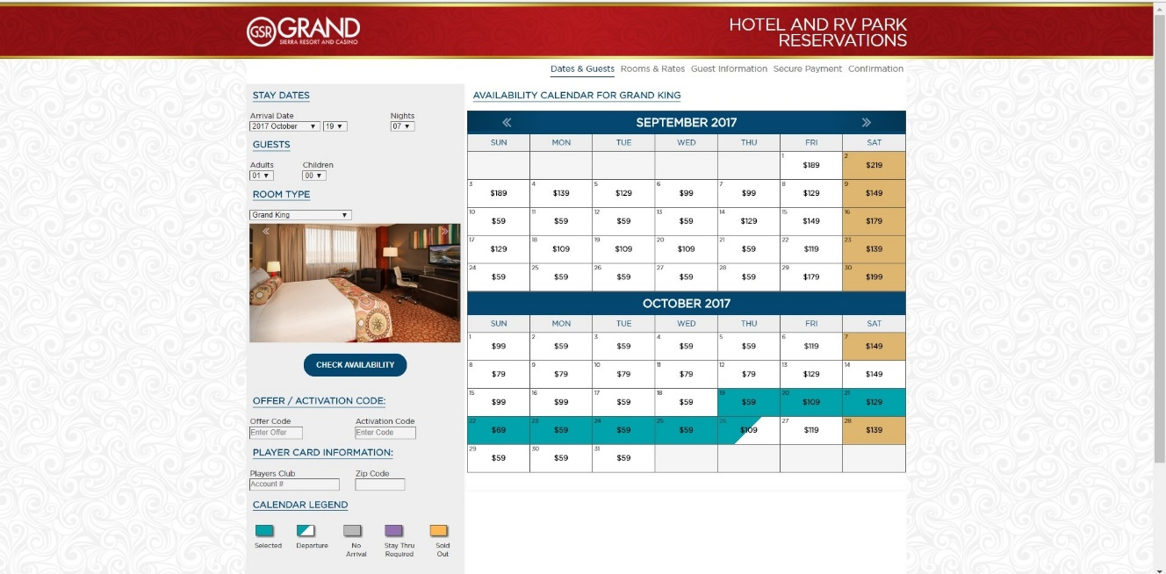*Figure 28: (Grand Sierra Hotel and Casino) Dates and Guest*

* The guest will provide his/her check-in and check-out date, how many the occupants would be (number of adult and children).
* The guest can choose which type of room he/she wants to reserve.
* The button "Check Availability" shows the available rooms and rates according to guest's inputs.

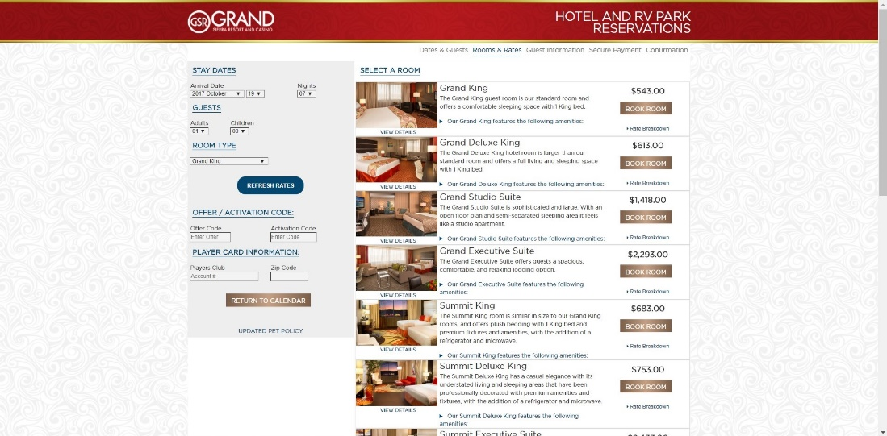*Figure 29: (Grand Sierra Hotel and Casino) Rooms and Rates*

* The guest can choose which room he/she wants to avail, this step as well shows the rates of the rooms.

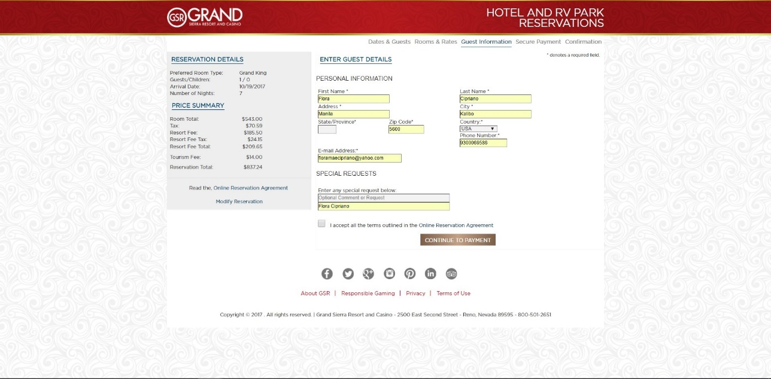*Figure 30: (Grand Sierra Hotel and Casino) Guest Information*

* + The guest must fill the Personal Information.
  + Stay Summary and Total cost ares shown at the left side of the page.

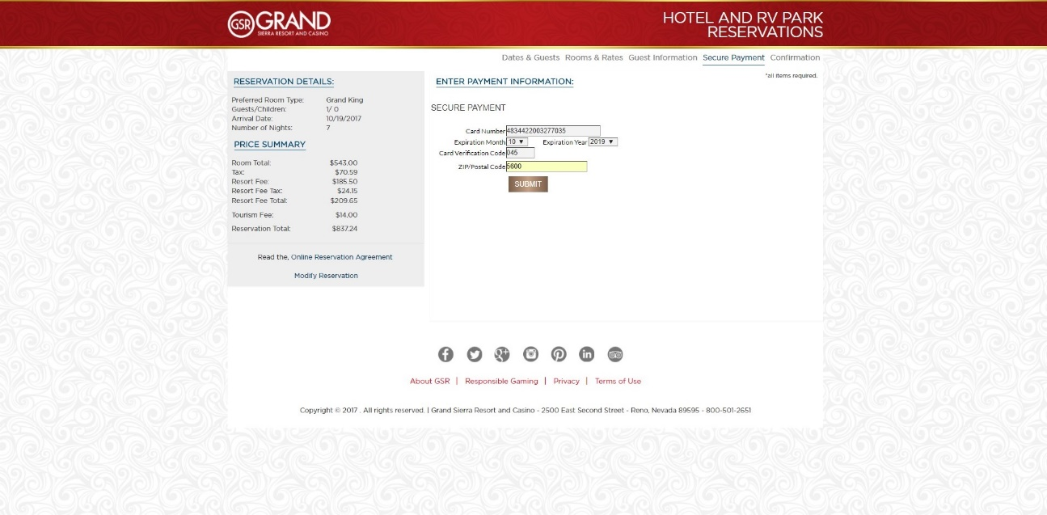*Figure 31: (Grand Sierra Hotel and Casino) Credit Card Guarantee*

* The guest must enter his/her credit card number, card's expiry date, CVC and postal code.
* The credit card used in this screenshot is for test purpose only.

**OMNI DALLAS HOTEL**

Omni Hotel was founded in 1958 owned by an American privately held, international luxury hotel based in Dallas, Texas. In present time, the group compromises over 60 hotels and resorts in key cities in the United States, Canada and Mexico. Omni Hotels exists to give guests an authentic feel for the local flavor in leading business gateways and leisure rooms. Omni Hotel is widely known as one of the finest and luxurious hotel and resort in the world.

The Omni Hotels believes by dedicating their selves to leave a lasting impression to every guest through personalized service, they create a unique memorable experience for their guest, a family associates that puts their soul in hospitality every day. They make sure to put first the needs of the guest, associate and owners in everything they do. Aside from the exceptional rooms they have, Omni Hotels provides various events to host and different amenities to its guests.

Omni Dallas Hotel formally opened in 2011 consist of 1001 rooms and suites with various types and rates. The building is located at Dallas, Texas, United States. One of the most striking features of the hotel is the LED lighting on the exterior, as for the word Omni means all, it shines above all. The hotel features several restaurants and bars. It has also a gift shop including Morsels Collections and local items such as Villy Custom a luxury fashion bicycles. With the features that the hotel has, the demand for guest is high without a doubt. The hotel promotes the use of their online reservation system through their website to lessen the inconvenience for their guest.

Omni Hotel provides a website to communicate with their guest from different parts of the world. They use a single website that has different sub domains categorized into their different branches. Their website is equipped with information regarding the hotel and its services; it also has an online reservation system that allows their guest to reserve for a room.

The following are screenshots of processes on how a guest reserves a room in Omni Dallas Hotel using its online reservation through their website.

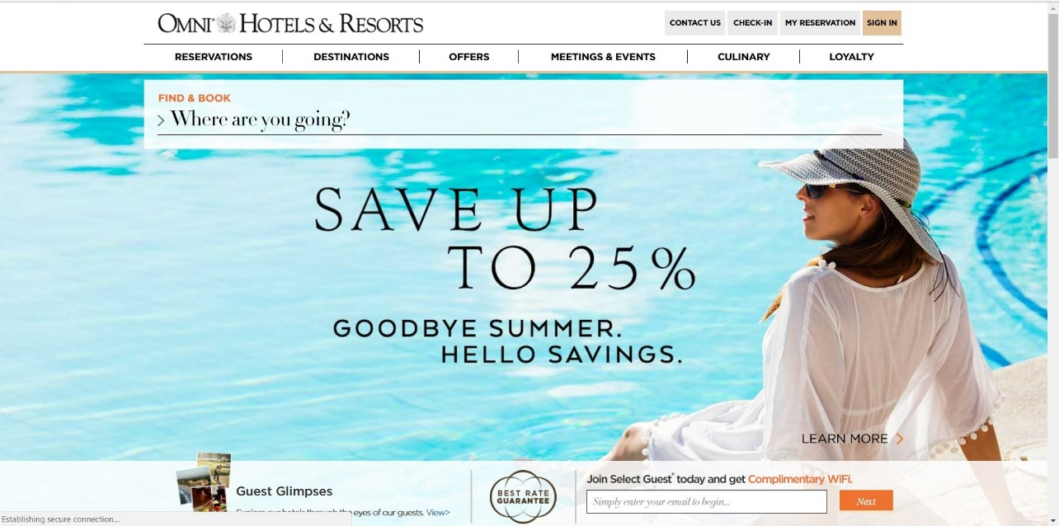*Figure 32: (Omni Dallas Hotel) Homepage*

* The guest can first view the services and features of the hotel.
* The "Reservation" will direct the guest to the reservation page.

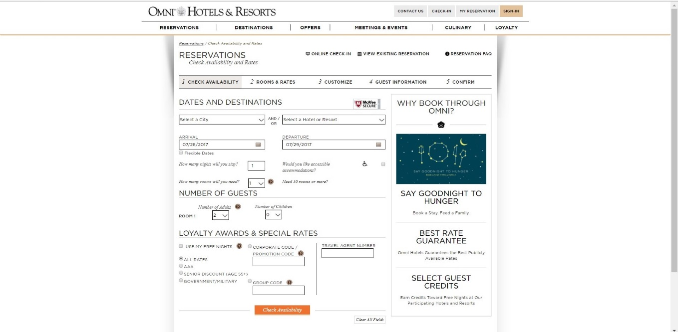

*Figure 33: (Omni Dallas Hotel) Room Reservation*

* The guest must select a city and/or select a Hotel or Resort.
* The guest will provide his/her check-in and check-out date.
* The guest must input how many the occupants would be (number of adults and children). He/she may add some more rooms.

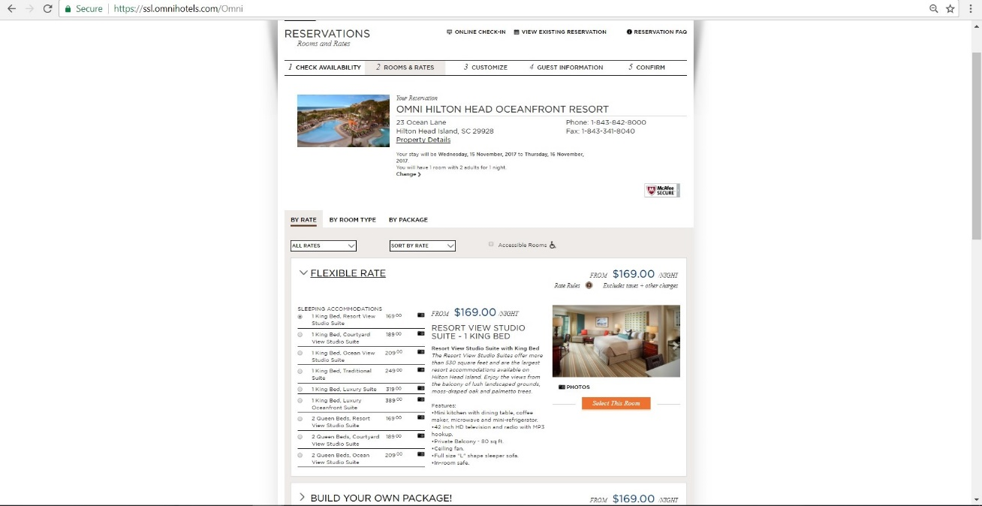

*Figure 34: (Omni Dallas Hotel) Rooms and Rates*

* The guest will choose which room he/she wants to avail.

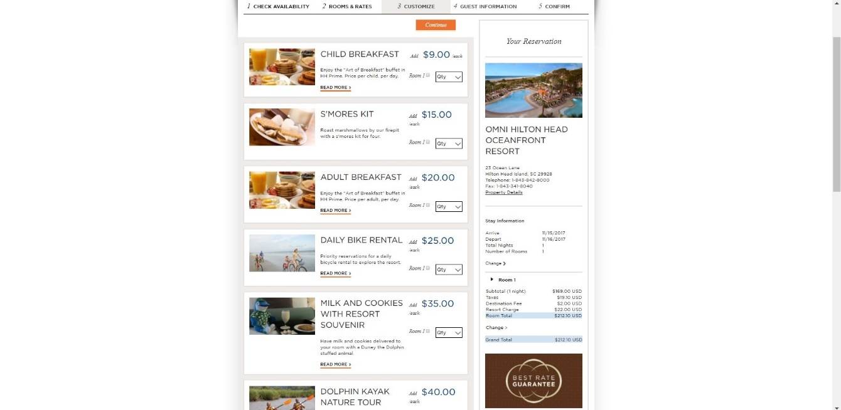

*Figure 35: (Omni Dallas Hotel) Customize*

* The guest can acquire the services that the hotel offers, he/she may just skip or continue this step if he/she does not want to avail the services.
* Stay Summary and Total Cost ares at the right side of the page.

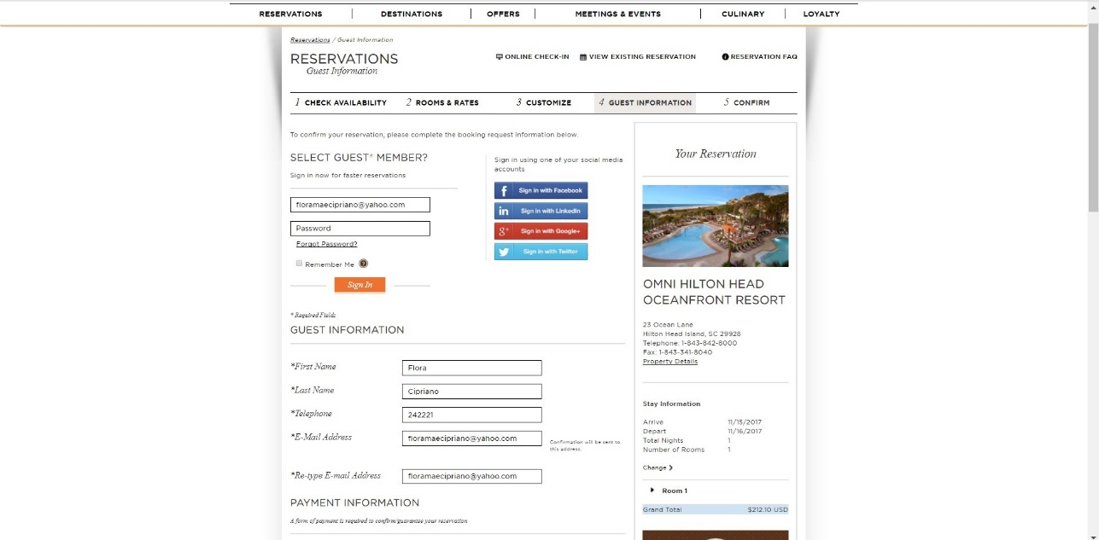*Figure 36: (Omni Dallas Hotel) Guest Information*

* + The guest may sign in using their membership account.
  + Or fill up his/her Personal Information.
  + Stay Summary and Total Cost are shown at the lower right side of the page.

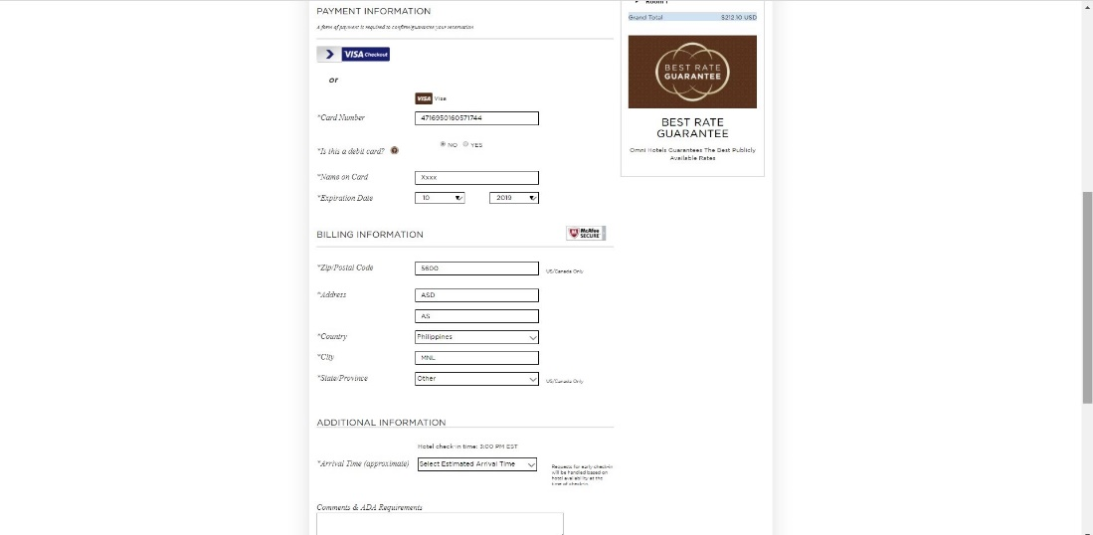

*Figure 37: (Omni Dallas Hotel) Payment Information*

* The guest's credit card number is used to hold his/her reservation. It will not be charged at booking.
* The guest must enter his/her card number and card's expiry date.
* The guest must input his/her country's zip code, address, country, city and province.
* The guest must indicate the estimated time of his/her arrival.
* Special remarks are also available for the guests.

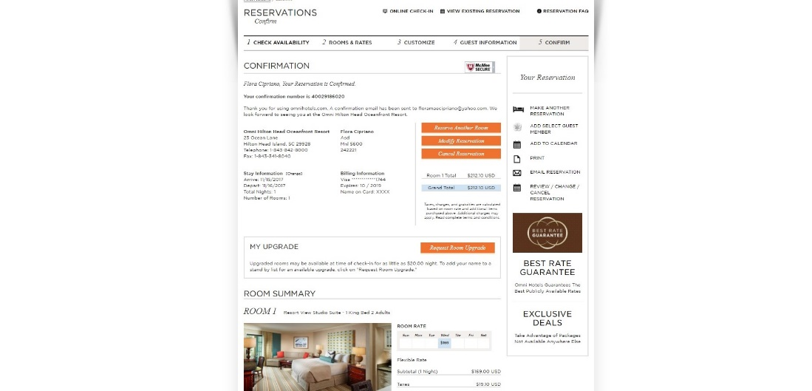*Figure 38: (Omni Dallas Hotel) Booking Confirmation*

* The guest will be given a Confirmation Number for a unique identification of their reservation.
* A confirmation e-mail will be received by the guest.
* Stay Summary and Total Cost are displayed.
* The guest can print this confirmation.

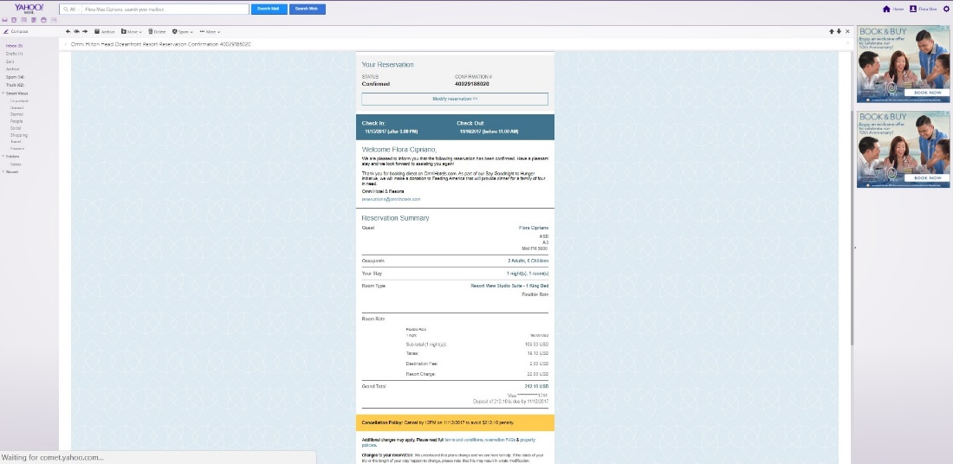

*Figure 39: (Omni Dallas Hotel) Confirmation E-mail*

* The confirmation e-mail contains the complete reservation details.

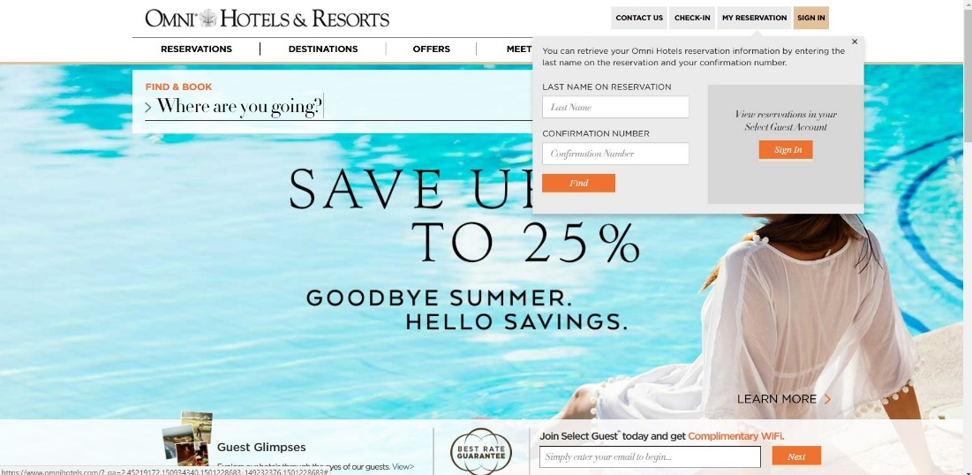*Figure 40: (Omni Dallas Hotel) View/Modify/Cancel Reservation 1*

* To view, modify and cancel existing reservation, the guest should navigate to homepage, click on My Reservation.
* The guest should enter his/her last name and confirmation number to continue.
* Or log-in via membership account.

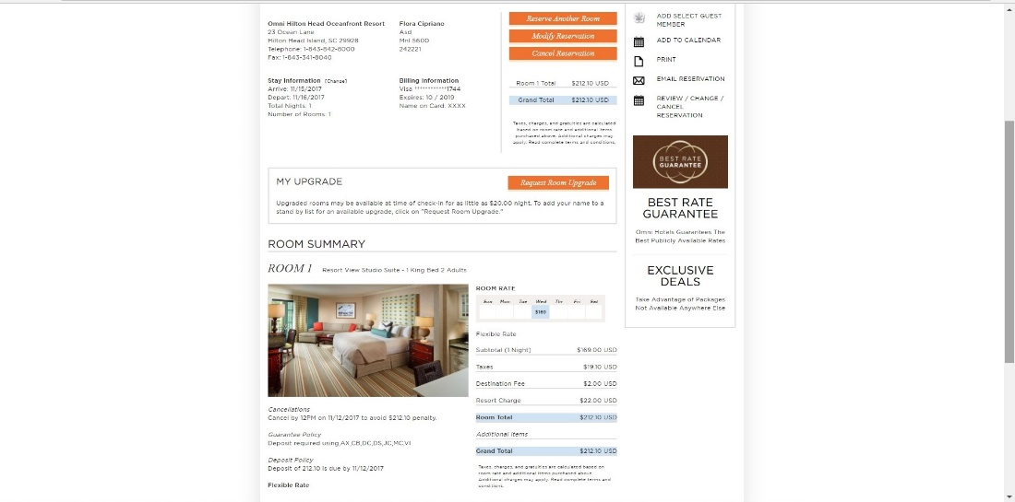

*Figure 41: (Omni Dallas Hotel) View/Modify/Cancel Reservation 2*

* The guest can also view his/her reservation details and may edit it.
* The cancellation button is at the right side of the page.
* Cancellation Policy is at the lower part of the page.

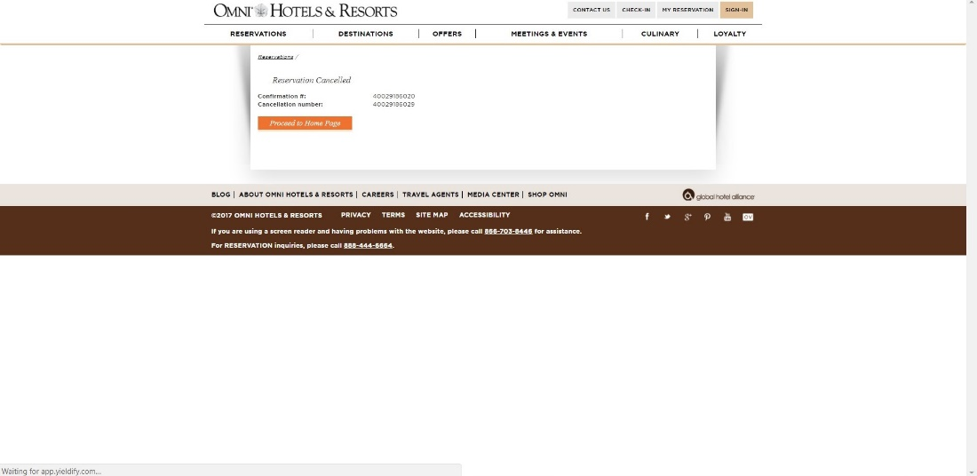

*Figure 42: (Omni Dallas Hotel) Cancel Reservation 2*

* After the Cancel Reservation button is clicked, the guest will receive a Cancellation Number.
* The cancellation number will serve as a unique identification of the cancelled reservation.

**ATLANTIS CASINO RESORT SPA**

Atlantis Casino Resort Spa was formerly known as Golden Road Motor Inn, [Travelodge](https://en.wikipedia.org/wiki/Travelodge), [Quality Inn](https://en.wikipedia.org/wiki/Choice_Hotels) and [Clarion](https://en.wikipedia.org/wiki/Choice_Hotels) it was built first as a Motel and purchased by Fahari family. It was also renovated from every change of the resort's name to its final name Atlantis Casino Resort Spa. The resort opened in 1972 starting first with a Motel type. In the present time, Atlantis Casino Resort Spa is widely known as one of the luxurious and finest resort in the world.

The resort is popular internationally with their finest and exceptional rooms and world-class services. They also host events like convention, weddings and family reunions and provide various amenities to its guest. The Atlantis Casino Resort Spa believes that focusing on making their guest stay a good one, makes their resort a world-class resort and the best one by the exceptional and friendly service and the special amenities they have been offering. Aside from their casino, one of their specialties is their eight restaurants, this was awarded as Wine's Spectator Award, which named Bistro Napa.

Atlantis Casino Resort Spa consists of 824 rooms and suites with various types and rates, the Jacuzzi suite is their best. The establishment is located at Virginia Reno, Nevada. Nestled at the base of Sierra Nevada mountain range and connected via sky bridge to the Reno Sparks Convention Center. In line with the tourist spot and the heart of Reno where the Resort is situated, Atlantis Casino Resort Spa being highly demanded resort promotes the use of their online reservation system through their website to elevate convenience for their guest from near or far.

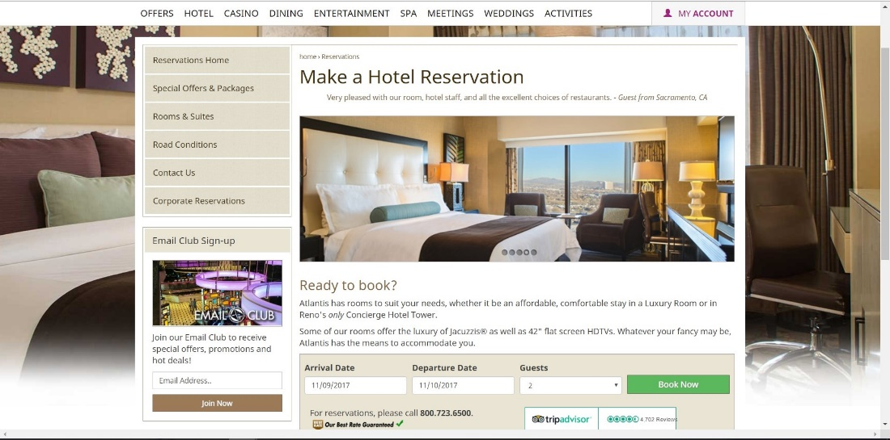Atlantis Casino Resort Spa provides a website to communicate with their guest and to present their resort's amenities and services. Their website is equipped with information regarding the resort and its services; it also has an online reservation system that allows their guest to reserve a room and avail various events that the resort can host.

*Figure 43: (Atlantis Casino Resort Spa) Homepage*

* The guest provides his/her check in and check-out.
* The guest must input how many the occupants would be.
* The button "Book Now" shows the available rooms and rates according to the guest's inputs.

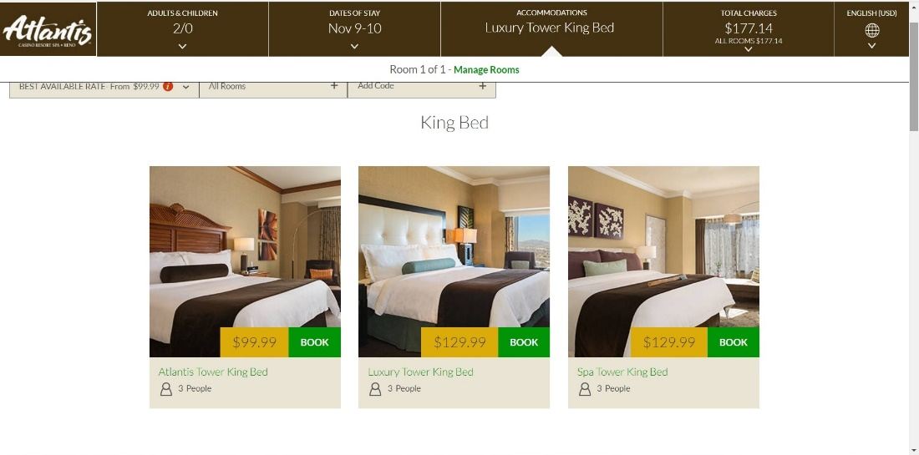*Figure 44: (Atlantis Casino Resort Spa) Room Reservation*

* After inputting the check-in and check-out, number of guest. The page will show the available rooms and its rate.
* If the guest wants to add a room or add occupants he/she may navigate to the upper part of the page "Adults/Children" to update the rooms and occupants.

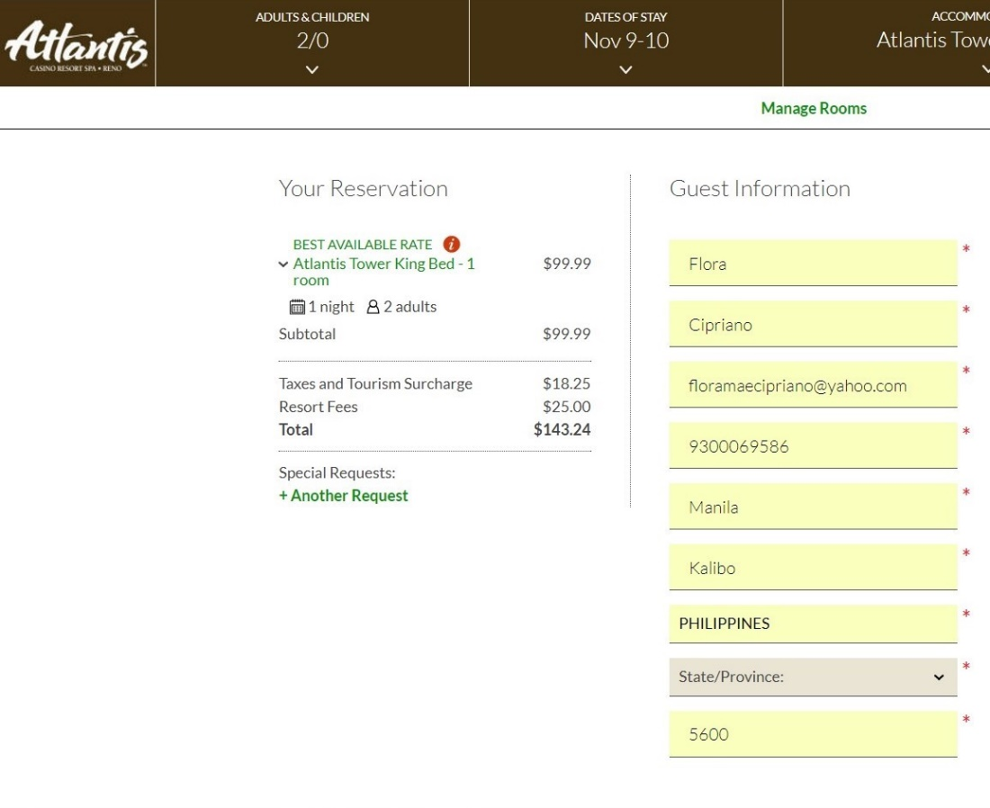*Figure 45: (Atlantis Casino Resort Spa) Guest Information*

* The guest must fill up Contact Information.
* Optional Request is also available when clicked.
* Stay Summary with Total cost are shown at the left side of the page.

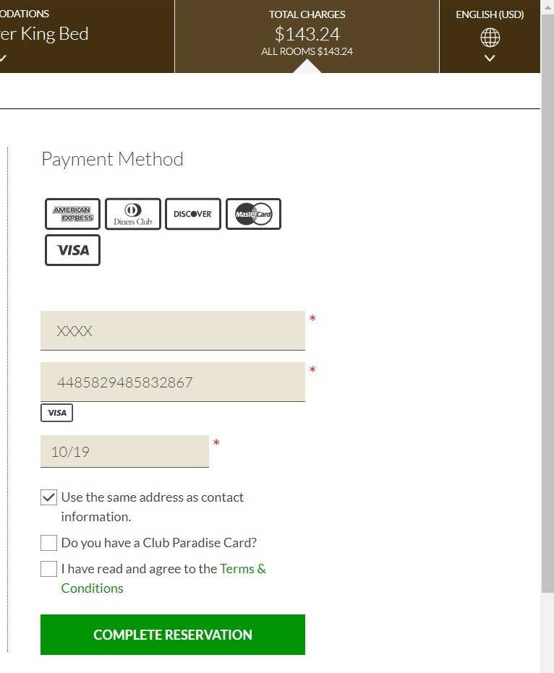

*Figure 46: (Atlantis Casino Resort Spa) Credit Card Guarantee*

* The guest's credit card number is used to hold his/her reservation. It will not be charged at booking.
* The guest must enter the card holder name, card number and card's expiry date.
* The credit card number used in this screenshot is for test purpose only.

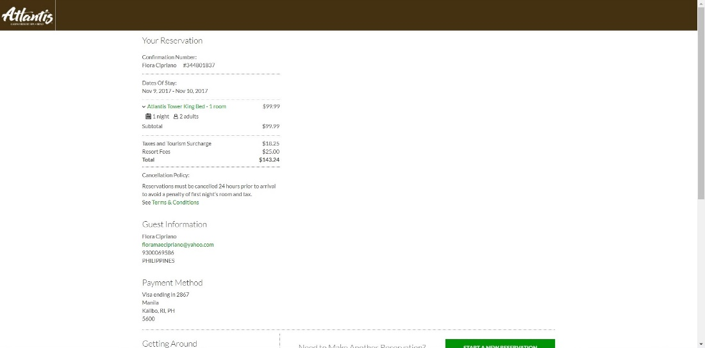

*Figure 47: (Atlantis Casino Resort Spa) Booking Confirmation*

* The guest will be given a Confirmation Number for a unique identification of their reservation.
* A confirmation e-mail will be received by the guest.
* Stay Summary and Total Cost are displayed.

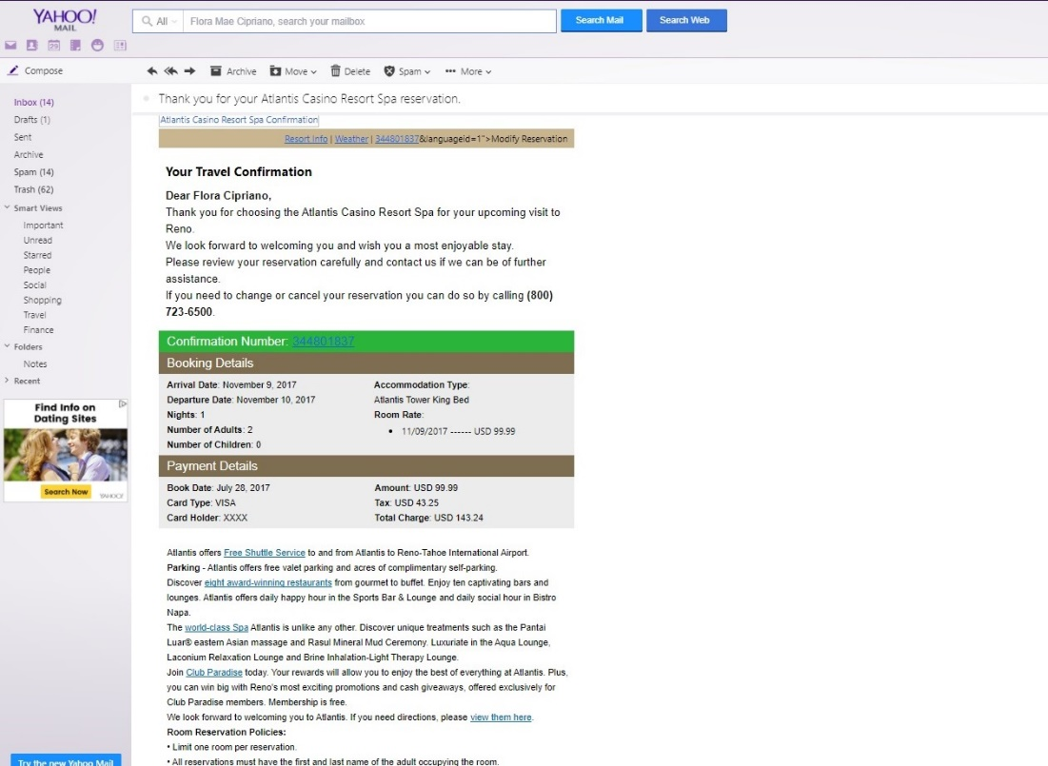

*Figure 48: (Atlantis Casino Resort Spa) Reservation Confirmation E-mail*

* The confirmation email contains the complete reservation details.

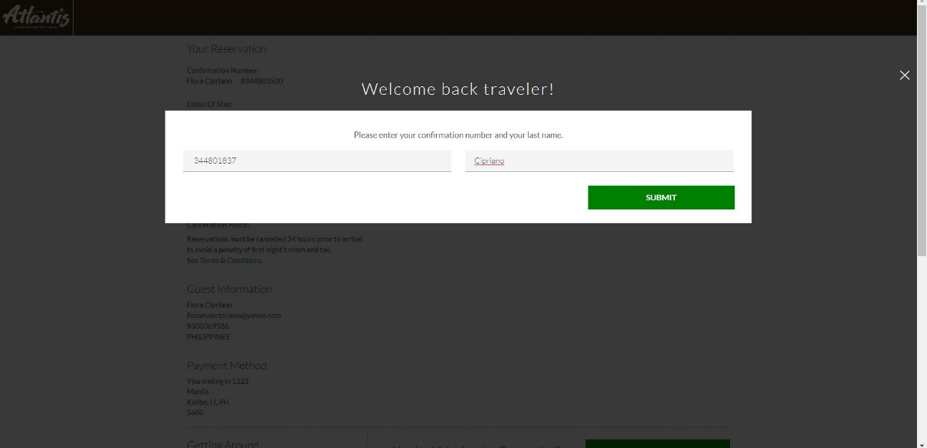

*Figure 49: (Atlantis Casino Resort Spa) View/Modify/Cancel Reservation 1*

* To view, modify and cancel existing reservation, the guest should make a reservation again the modify/cancel will then appear at the bottom part of the page, to have Modify/Cancel.
* The guest should enter given reservation number and his/her family/last name.
* Another option for cancelling the reservation is to call the resort directly.

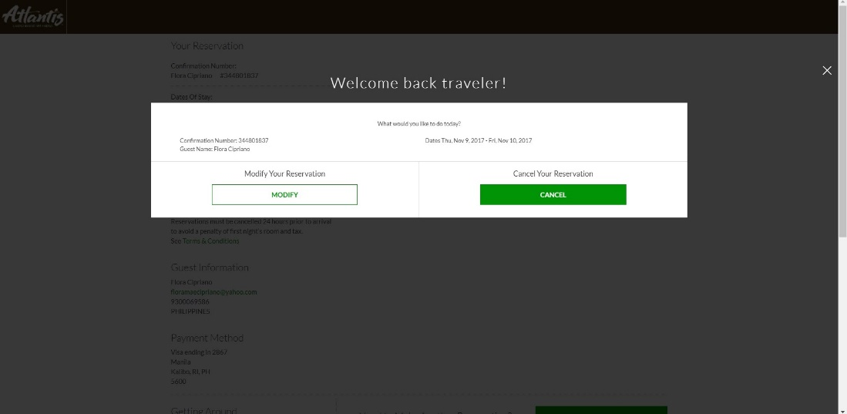

*Figure 50: (Atlantis Casino Resort Spa) View/Modify/Cancel Reservation 2*

* The guest can also view his/her reservation details and may edit it.
* The cancellation button is at the right side of the page.

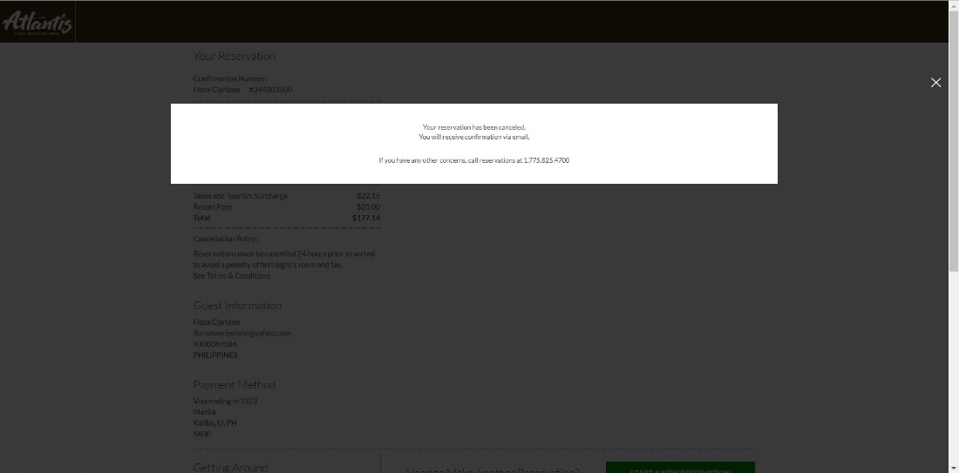

*Figure 51: (Atlantis Casino Resort Spa) Cancel Reservation*

* After the Cancel Reservation button is clicked, the guest will receive a Cancellation Number.
* The cancellation number will serve as a unique identification of the cancelled reservation.

**SYNTHESIS**

The proponents will relatively base the developed system from the adequate ideas generated by the Local and Foreign Hotel Online Reservation System. The proponents specifically will imitate the systems' reservation flow which is very convenient for the guest for it dominates a step-by-step procedure. The system is a little bit complicated because of the extensive features and services which the proponents already expected, in reason for this the proponents will make the developed system simpler but still captivating, interactive and user-friendly.

The proponents experienced how to simulate an online reservation process in the guest's perspectives through different systems locally and internationally. For what the proponents have observe, locally or internationally the flow of the system is just the same, some systems will just add a feature to make it more informative and appealing to the guest eyes. The proponents used a card generator to test the reservation system. In the first step, the verification of room availability takes place by matching the dates and number of occupants inputted by the guest with reservation records currently stored. At some system, the numbers of occupants are not yet to be inputted. The next page will show the available rooms and their rates. The second step is selecting an available room to be reserved. After choosing a suitable room it will now go to third step of reservation: supplying guest's contact information, adding special request, and guaranteeing reservation with a credit card. (The credit card used by the proponent upon booking was redeemed in <http://www.getcreditcardnumbers.com/>, which generates valid credit card numbers for testing purposes only. The website generator does not advise to use the numbers for any actual transactions and it does not condone nor promote fraudulent acts.) The fourth step is confirming the guest that a reservation has been done. A generated confirmation number will be given to the guest. An e-mail will be sent to the guest as well to confirm his/her booking.

The proponents will aim to focus on this flow and these four easy steps since most hotels and resorts also have this kind of flow in their reservation system. The systems' presented will be a great contributor to the success of the project.

**OPERATIONAL DEFINITION OF TERMS**

***Administrator***

The hierarchy user that can view reports, add, modify and delete user access and manipulate what is in the system. Also, a person who is responsible to manage staffs and run the business at the same time.

***Amenities***

A useful facility of a place that is offered to the guests, clients or customers. It provides the guests, clients or customers a satisfaction while staying at the resort.

***Backup files***

A copy of files or records that the client can use when their files are lost or corrupted. It is also a way of assuring that the files are safely stored with not only one source.

***Billing***

A process of giving an invoice or bill to customers, this process shows the total cost of the fees that the guests, customers or clients have availed while they’re at the hotel.

***Cancellation***

A process of cancelling the reservation, it is a convenient way for the user to easily cancel his/her reservation through the use of the system.

***Check-in***

The act of going to a resort or hotel and report to the front desk that the customers have arrived in the resort, hotel etc. and avail what they pay for such as their reserved room or services.

***Check-out***

The act of leaving the resort or hotel room after clients finished their schedule for stay-in. It is also a process of settling the bills to be paid before leaving the resort or hotel.

***Facilities***

A place, amenity, or piece of equipment provided as a purpose. It is an add on to the resort that the guest can freely access or use.

***Front desk***

It refers to a person who manages and tracks the reservation of the guests. As well as, answering or referring inquiries on the telephone and walk-in guests.

***Guest***

The main user of the system who inquires and acquires reservation of the company for a stay-in. Also, gives feedback and suggestions about their experience in the specific resort.

***Invoice***

A billing statement and document that indicates the brief descriptions, prices, amount of total and balance payment and costs of the guests provided by the resort.

***Magnetic Key Card***

A modern door security pass used by Bataan White Corals Beach Resort or other resort and hotels to access or lock the guest room.

***Manual Reservation***

A process wherein a guest physically books or reserves by inputting the data needed usually done by using pen and paper.

***Modify***

A process of editing the recent inputted data of the user, it lets the user add, delete or view the information she/he already saved or inputted.

***Online***

It is a term used to define a process or transactions that is connected to or controlled by the system and is also connected to a network.

***Proponents***

The group of people or organization advocates and conducts a research or project proposal to a company. Also, they determine and discuss all the contents and concepts of the whole project.

***Reimbursement***

An amount being refunded or pay back someone’s money for the expenses or costs. This occurs when customers or guests cancel their reservation.

***Reservation***

A process of acquiring available rooms, facilities and amenities of a company. An act of reserving an arrangement for the use of one’s needs such as rooms and services.

***Resort***

A place where a lot of people go for a vacation to relax and to have fun. Bataan White Corals Beach Resort is one example of a resort.

***Salt water pool***

A type of swimming pool that contains water from the sea which Bataan White Corals Beach Resort uses. It offers or provides a new experience to guests in the resort to swim with rather than an ordinary swimming pool.

***System***

An operation which can be manually or automatically operates procedures of all transactions for reservation of Bataan White Corals Beach Resort.

***Walk-in reservation***

Guests who come to the resort personally to make a reservation. Also, pay directly in cash to the resort.

***Website***

It refers to the location on the Internet that contains and maintains webpages and data files through a web browser and to provide and display more details about the resort or other topic and study.